**Annex-I**





Monthly Review

on

Price Indices

September 2025

(Base Year 2015-16)

**Government of Pakistan**

**Ministry of Planning, Development & Special Initiatives**

**Pakistan Bureau of Statistics**

**Islamabad**

# PRICE STATISTICS TEAM

|  |  |  |
| --- | --- | --- |
| **S#** | **Name** | **Designation** |
| 1. 1 | Dr. Naeem Uz Zafar (S.I) | Chief Statistician |
|  | Dr. Bahrawar Jan | Deputy Director General |
|  | Mr. Naseer Ahmad | Director |
| 1. 2 | Dr. Ahtasham Gul | Chief Statistical Officer |
| 1. 3 | Mr. Kashif Ali | Statistical Officer |
| 1. 6 | Miss. Umaira Zareen | Statistical Officer |
|  | Mr. Abdul Qadir | Statistical Officer |
|  | Mrs. Safia Akram | Statistical Officer |
|  | Mrs. Faiza Razzaq | Statistical Officer |
|  | Mr. Umer Farooq | Statistical Officer |
| 11. | Mr. Ansar Mahmood | Statistical Assistant |
| 12. | Mrs. Madiha Gulfraz | Statistical Assistant |
| 13.  14. | Mrs. Humail Fatima  Mr. Muhammad Asif | Statistical Assistant  Statistical Assistant |

**IT & SOFTWARE TEAM**

|  |  |  |
| --- | --- | --- |
| 1. | Mr. Muhammad Sarwar Gondal (S.I) | Member (Support Services) |
| 2.  3.  4. | Mr. Muhammad Ehtesham  Mrs. Sobia Munawar  Mr. Arsalan Bashir | Director (DP)  Director (DP)  Chief System Analyst |
| 5. | Mr. Muhammad Kibria | Data Processing Officer |
| 6. | Mr. Irfan Bajwa | Data Processing Officer |

**Inflation in Brief**

1. **CPI inflation General**, increased by 5.6**%** on year-on-year basis in September 2025 as compared to 3.0**%** of the previous month and 6.9% in September 2024. On month-on-month basis, it increased by 2.0% in September 2025 as compared to a decrease of 0.6% in the previous month and a decrease of 0.5% in September 2024.
2. **CPI inflation Urban**, increased by 5.5**%** on year-on-year basis in September 2025 as compared to 3.4**%** of the previous month and 9.3% in September 2024. On month-on-month basis, it increased by 1.5% in September 2025 as compared to a decrease of 0.7% in the previous month and a decrease of 0.5% in September 2024.
3. **CPI inflation Rural**, increased by 5.8% on year-on-year basis in September 2025 as compared to an increase of 2.4% in the previous month and 3.6% in September 2024. On month-on-month basis, it increased by 2.8**%** in September 2025 as compared to a decrease of 0.5**%** in the previous month and in September 2024.
4. **SPI inflation** on YoY basis increased by 4.5**%** in September 2025 as compared to an increase of 2.6**%** a month earlier and an increase of 9.2% in September 2024. On MoM basis, it increased by 2.0% in September 2025 as compared to 3.2% in a month earlier and an increase of 0.2% in September 2024.
5. **WPI inflation** on YoY basis increased by 0.6% in September 2025 as compared to a decrease of 1.0% in the previous month and an increase of 1.9% in September 2024. On month-on-month basis, it increased by 0.5% in September 2025 as compared to a decrease of 0.2% in the previous month and 1.1% in September 2024.
6. Figures 1 and 2 show graphically the yearly data of Table 1.a for Urban and Rural CPI while Table 1.1 shows “Period Average” and “YoY” percentage changes in indices.

|  |  |  |  |  |  |  |  |  |  |  |  |  |  |  |  |  |  |  |
| --- | --- | --- | --- | --- | --- | --- | --- | --- | --- | --- | --- | --- | --- | --- | --- | --- | --- | --- |
| **Table 1.a General Inflation (%) (Base 2015-16)** | | | | | | | | | | | | | | | | | | |
| **PERIOD** | **CPI** | | | | | | | | | | | | | | **SPI\*\*** | | **WPI** | |
| **General** | | | | | | **Food** | | | | **Non-Food** | | | |
| **National** | | **Urban** | | **Rural** | | **Urban** | | **Rural** | | **Urban** | | **Rural** | |
| **YoY** | **MoM** | **YoY** | **MoM** | **YoY** | **MoM** | **YoY** | **MoM** | **YoY** | **MoM** | **YoY** | **MoM** | **YoY** | **MoM** | **YoY** | **MoM** | **YoY** | **MoM** |
| Dec-23 | 29.7 | 0.8 | 30.9 | 0.7 | 27.9 | 1.0 | 28.8 | -0.7 | 29.3 | 0.1 | 32.4 | 1.8 | 26.4 | 1.8 | 35.3 | 3.8 | 27.3 | 0.0 |
| Jan-24 | 28.3 | 1.8 | 30.2 | 1.8 | 25.7 | 1.9 | 27.4 | 2.8 | 25.1 | 2.3 | 32.3 | 1.1 | 26.3 | 1.4 | 36.2 | 2.0 | 27.0 | 1.5 |
| Feb-24 | 23.1 | 0.0 | 24.9 | 0.2 | 20.5 | -0.3 | 20.2 | -1.5 | 19.0 | -1.1 | 28.2 | 1.5 | 22.1 | 0.6 | 30.4 | -0.8 | 18.7 | 1.1 |
| Mar-24 | 20.7 | 1.7 | 21.9 | 1.4 | 19.0 | 2.1 | 16.6 | 2.4 | 17.1 | 2.8 | 25.8 | 0.7 | 21.0 | 1.4 | 25.9 | 2.1 | 14.8 | 1.3 |
| Apr-24 | 17.3 | -0.4 | 19.4 | -0.1 | 14.5 | -0.9 | 11.3 | -1.3 | 9.5 | -2.6 | 25.6 | 0.8 | 20.0 | 0.8 | 21.6 | -0.7 | 13.9 | -0.7 |
| May-24 | 11.8 | -3.2 | 14.3 | -2.8 | 8.2 | -3.9 | 2.2 | -6.3 | -0.1 | -7.4 | 23.6 | -0.4 | 17.2 | -0.4 | 15.3 | -4.0 | 9.9 | -2.5 |
| June-24 | 12.6 | 0.5 | 14.9 | 0.6 | 9.3 | 0.3 | 2.6 | 0.4 | 1.3 | -0.2 | 24.3 | 0.7 | 17.9 | 0.8 | 16.6 | 1.3 | 10.6 | 0.4 |
| July-24 | 11.1 | 2.1 | 13.2 | 2.0 | 8.1 | 2.2 | 3.4 | 4.5 | 1.3 | 3.6 | 20.7 | 0.5 | 15.5 | 0.9 | 15.7 | 2.0 | 10.4 | 2.3 |
| Aug-24 | 9.6 | 0.4 | 11.7 | 0.3 | 6.7 | 0.6 | 4.1 | 1.3 | 1.9 | 1.3 | 17.4 | -0.4 | 11.9 | -0.2 | 10.8 | -0.3 | 6.3 | 0.3 |
| **Sep-24** | **6.9** | **-0.5** | **9.3** | **-0.5** | **3.6** | **-0.5** | **1.7** | **-0.8** | **-0.9** | **-1.0** | **15.0** | **-0.3** | **8.4** | **-0.1** | **9.2** | **0.2** | **1.9** | **-1.1** |
| Oct-24 | 7.2 | 1.2 | 9.3 | 1.1 | 4.2 | 1.5 | 2.7 | 1.6 | 0.6 | 2.2 | 14.2 | 0.7 | 8.0 | 0.8 | 9.7 | 0.6 | 3.9 | 0.0 |
| Nov-24 | 4.9 | 0.5 | 5.2 | 0.5 | 4.3 | 0.5 | 1.7 | -0.2 | -0.2 | 0.2 | 7.8 | 1.0 | 9.1 | 0.8 | 7.3 | 1.0 | 2.3 | -0.1 |
| Dec-24 | 4.1 | 0.1 | 4.4 | -0.1 | 3.6 | 0.3 | 2.5 | 0.1 | -0.2 | 0.1 | 5.7 | -0.2 | 7.6 | 0.5 | 4.2 | 0.8 | 1.9 | -0.4 |
| Jan-25 | 2.4 | 0.2 | 2.7 | 0.2 | 1.9 | 0.2 | -0.6 | -0.3 | -2.9 | -0.4 | 5.0 | 0.5 | 7.0 | 0.9 | 0.7 | -1.4 | 0.6 | 0.2 |
| Feb-25 | 1.5 | -0.8 | 1.8 | -0.7 | 1.1 | -1.1 | -0.9 | -1.8 | -4.3 | -2.5 | 3.6 | 0.1 | 6.6 | 0.3 | -0.2 | -1.6 | -0.7 | -0.2 |
| Mar-25 | 0.7 | 0.9 | 1.2 | 0.8 | 0.0 | 1.1 | -1.7 | 1.6 | -5.4 | 1.6 | 3.1 | 0.2 | 5.6 | 0.5 | -2.3 | -0.1 | -1.6 | 0.3 |
| Apr-25 | 0.3 | -0.8 | 0.5 | -0.7 | -0.1 | -1.0 | -1.9 | -1.6 | -4.6 | -1.8 | 2.2 | -0.1 | 4.4 | -0.4 | -3.6 | -2.1 | -2.2 | -1.3 |
| May-25 | 3.5 | -0.2 | 3.5 | 0.1 | 3.4 | -0.5 | 5.3 | 0.6 | 2.1 | -1.0 | 2.4 | -0.3 | 4.6 | -0.1 | -0.6 | -1.0 | 0.4 | 0.0 |
| June-25 | 3.2 | 0.2 | 3.0 | 0.1 | 3.6 | 0.5 | 4.2 | -0.6 | 2.4 | 0.1 | 2.2 | 0.5 | 4.7 | 0.8 | -1.9 | 0.0 | 0.6 | 0.6 |
| July-25 | 4.1 | 2.9 | 4.4 | 3.4 | 3.5 | 2.2 | 2.2 | 2.4 | 1.5 | 2.7 | 5.9 | 4.1 | 5.4 | 1.6 | -0.9 | 3.1 | -0.5 | 1.2 |
| Aug-25 | 3.0 | -0.6 | 3.4 | -0.7 | 2.4 | -0.5 | -0.5 | -1.3 | -0.5 | -0.7 | 5.9 | -0.4 | 5.2 | -0.4 | 2.6 | 3.2 | -1.0 | -0.2 |
| **Sep-25** | **5.6** | **2.0** | **5.5** | **1.5** | **5.8** | **2.8** | **4.4** | **4.0** | **6.0** | **5.5** | **6.2** | **0.0** | **5.6** | **0.3** | **4.5** | **2.0** | **0.6** | **0.5** |

**\*\* SPI for quintile 1. Digits 0.0* are due to rounding off.**

**Core inflation (NFNE)**

1. Measured by **non-food non-energy Urban** increased by 7.0% on (YoY) basis in September 2025 as compared to 6.9% of the previous month and 9.3% in September 2024. On (MoM) basis, it remained stable at 0.3**%** in September 2025 as well as in previous month and an increase of 0.2% in the corresponding month of last year i.e. September 2024.
2. Measured by **non-food non-energy Rural** remained stable at 7.8% on (YoY) basis in September 2025 as well as in previous month and an increase of 12.1% in September 2024. On (MoM) basis, it increased by 0.6% in September 2025 as compared to 0.2% in the previous month and an increase of 0.5% in corresponding month of last year i.e. September 2024.

**Core inflation (Trimmed)**

1. Measured by 20% **weighted trimmed mean** **Urban** increased by 5.7**%** on (YoY) basis in September 2025 as compared to 4.2**%** of the previous month and 7.1% in September 2024. On (MoM) basis, it increased by 0.3% in September 2025 as compared to no change in the previous month and a decrease of 0.1% in corresponding month of last year i.e. September 2024.
2. Measured by 20% **weighted trimmed mean** **Rural** increased by 6.5**%** on (YoY) basis in September 2025 as compared to an increase of 3.6**%** of the previous month and 7.4% in September 2024. On (MoM) basis, it increased by 0.7**%** in September 2025 as compared to an increase of 0.3**%** in the previous month and a decrease of 0.1% in corresponding month of last year i.e. September 2024.

|  |  |  |  |  |  |  |  |  |  |
| --- | --- | --- | --- | --- | --- | --- | --- | --- | --- |
| **Table 1.b Core Inflation (%) (Base 2015-16)** | | | | | | | | | |
| **Period** | **NFNE** | | | | **Trimmed** | | | | |
| **Urban** | | **Rural** | | **Urban** | | **Rural** | | |
| **YoY** | **MoM** | **YoY** | **MoM** | **YoY** | **MoM** | **YoY** | **MoM** |
| Sep-24 | 9.3 | 0.2 | 12.1 | 0.5 | 7.1 | -0.1 | 7.4 | -0.1 |
| Oct-24 | 8.6 | 0.6 | 11.7 | 0.7 | 6.4 | 0.7 | 7.2 | 1.0 |
| Nov-24 | 8.9 | 1.2 | 10.9 | 0.7 | 7.5 | 0.6 | 7.8 | 0.5 |
| Dec-24 | 8.1 | 0.2 | 10.7 | 0.6 | 6.2 | 0.1 | 6.5 | 0.6 |
| Jan-25 | 7.8 | 0.8 | 10.4 | 0.9 | 5.4 | 0.6 | 5.4 | 0.7 |
| Feb-25 | 7.8 | 0.3 | 10.4 | 0.4 | 4.6 | 0.1 | 5.2 | 0.1 |
| Mar-25 | 8.2 | 0.5 | 10.2 | 0.7 | 4.8 | 0.3 | 4.8 | 0.4 |
| Apr-25 | 7.4 | 1.3 | 9.0 | 0.9 | 3.8 | 0.3 | 3.3 | -0.1 | |
| May-25 | 7.3 | 0.4 | 8.8 | 0.4 | 4.9 | 0.1 | 4.7 | -0.2 | |
| June-25 | 6.9 | 0.2 | 8.6 | 0.7 | 4.7 | 0.3 | 5.2 | 0.5 | |
| July-25 | 7.0 | 0.8 | 8.1 | 0.7 | 5.1 | 1.0 | 4.9 | 0.7 | |
| Aug-25 | 6.9 | 0.3 | 7.8 | 0.2 | 4.2 | 0.0 | 3.6 | 0.3 | |
| Sep-25 | **7.0** | **0.3** | **7.8** | **0.6** | **5.7** | **0.3** | **6.5** | **0.7** | |

|  |  |  |  |  |  |  |
| --- | --- | --- | --- | --- | --- | --- |
| **Table 1.1 Period Average and Y-o-Y % Change** | | | | | |  |
| **INDEX** | **Average July - September**  **% Changes** | | | **September over September**  **% Changes** | | |
| **2025-2026** | **2024-2025** | **2023-2024** | **2025-2026** | **2024-2025** | **2023-2024** |
| **CPI (National)** | 4.22 | 9.19 | 29.04 | 5.61 | 6.93 | 31.44 |
| **CPI (Urban)** | 4.43 | 11.37 | 26.98 | 5.49 | 9.29 | 29.74 |
| **CPI (Rural)** | 3.91 | 6.14 | 32.02 | 5.78 | 3.65 | 33.88 |
| **SPI** | 2.07 | 11.87 | 29.75 | 4.47 | 9.21 | 32.00 |
| **WPI** | -0.30 | 6.10 | 24.61 | 0.59 | 1.95 | 26.39 |

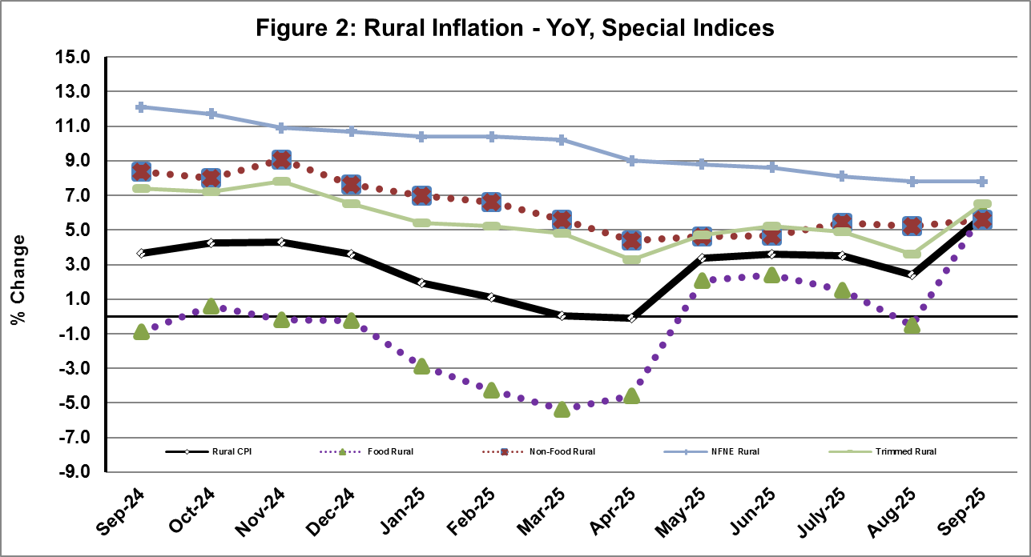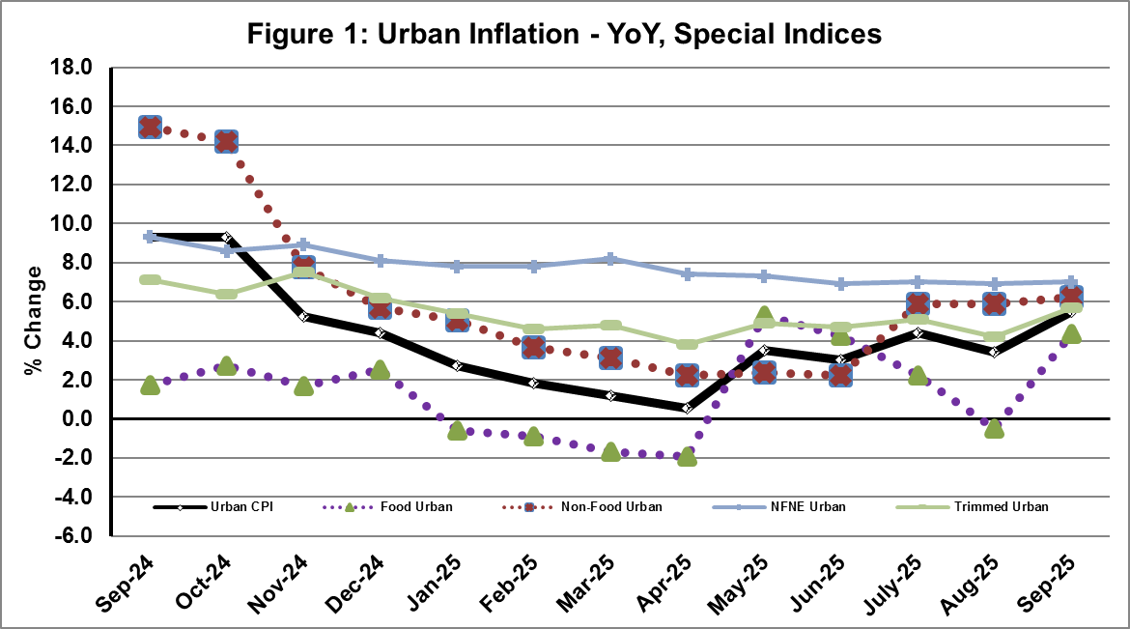

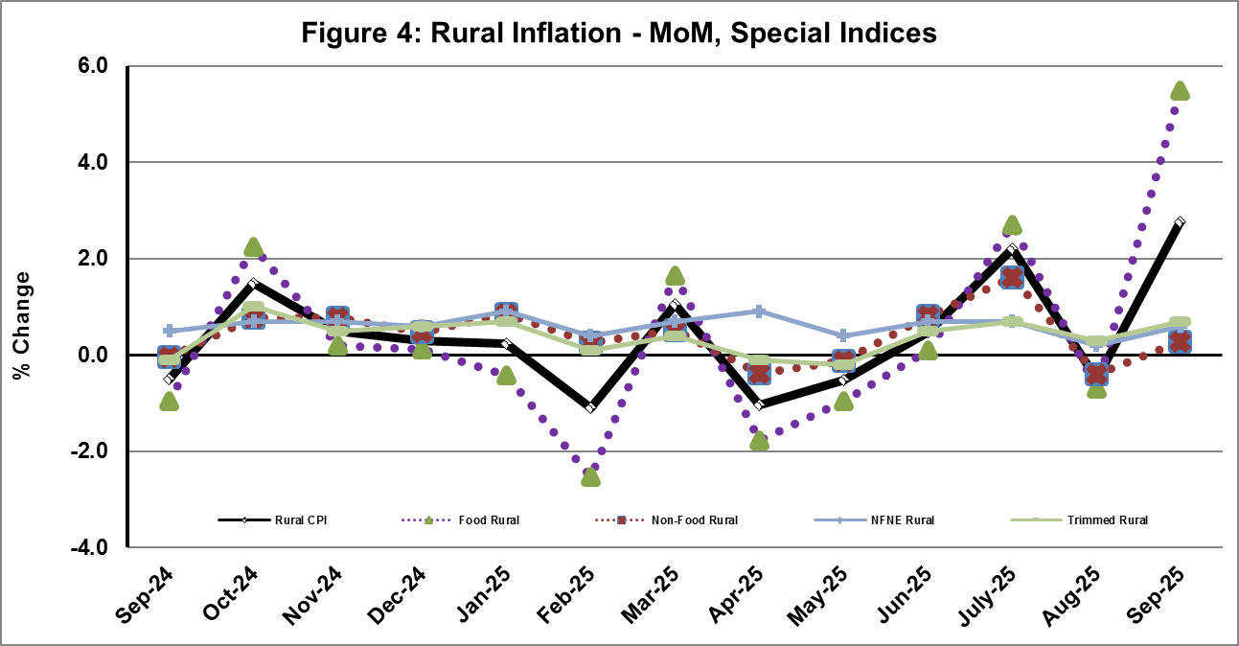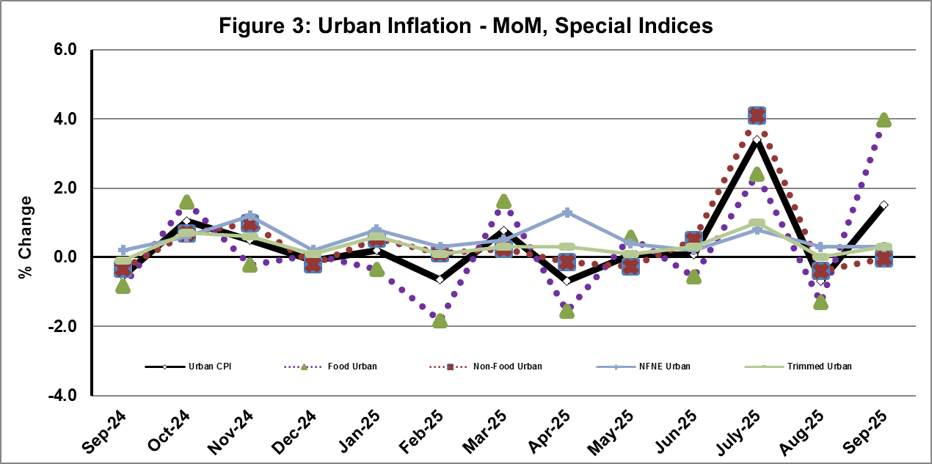

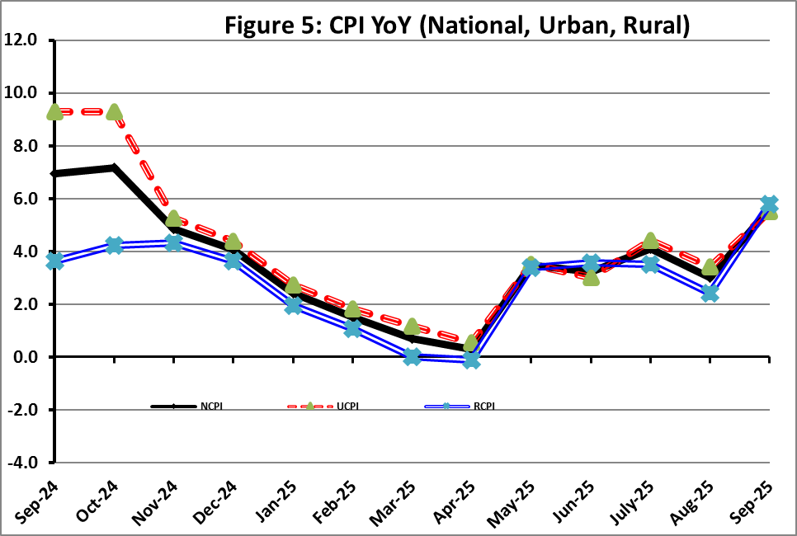

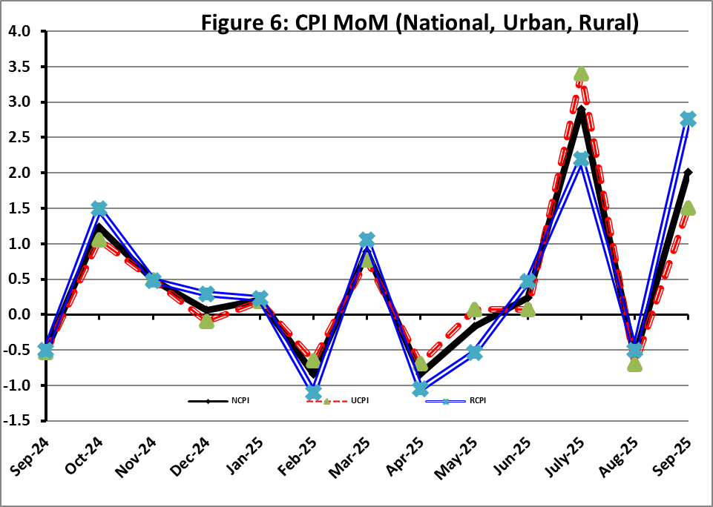

**I. National Consumer Price Index (NCPI)**

The **National Consumer Price Index** for **September 2025** is increased by **2.01%** over **August 2025** and increased by **5.61%** over corresponding month of the last year i.e. **September 2024**.

|  |  |  |  |  |  |  |  |  |  |
| --- | --- | --- | --- | --- | --- | --- | --- | --- | --- |
| Table 1: Consumer Price Index (National) by Group of Commodities and Services (Base 2015-16) | | | | | | | | | |
| No | Group | Group  Weight  (%) | Indices | | | % Change  Sep 2025  Over | | Impact  (In % points)  Sep 2025 Over | |
| Sep 25 | Aug 25 | Sep 24 | Aug 25 | Sep 24 | Aug 25 | Sep 24 |
| General | 100.00 | **275.60** | **270.18** | **260.96** | **2.01** | **5.61** | **2.01** | **5.61** |
| 1. | Food & Non-alcoholic Bev. | 34.58 | 290.74 | 275.70 | 276.85 | 5.46 | 5.02 | 1.93 | 1.84 |
|  | *Non-perishable Food Items* | 29.60 | 293.59 | 281.20 | 275.59 | 4.41 | 6.53 | 1.36 | 2.04 |
| *Perishable Food Items* | 4.99 | 273.83 | 243.08 | 284.32 | 12.65 | -3.69 | 0.57 | -0.20 |
| 2. | Alcoholic Bev. & Tobacco | 1.02 | 398.28 | 397.79 | 385.24 | 0.12 | 3.39 | 0.00 | 0.05 |
| 3. | Clothing & Footwear | 8.60 | 265.79 | 264.70 | 246.11 | 0.41 | 8.00 | 0.03 | 0.65 |
| 4. | Housing, Water, Electricity, Gas & Fuels | 23.63 | 244.12 | 245.49 | 235.52 | -0.56 | 3.65 | -0.12 | 0.78 |
| 5. | Furnishing & Household Equipment Maintenance | 4.10 | 280.52 | 279.69 | 269.38 | 0.30 | 4.13 | 0.01 | 0.17 |
| 6. | Health | 2.79 | 279.49 | 277.20 | 252.74 | 0.83 | 10.59 | 0.02 | 0.29 |
| 7. | Transport | 5.91 | 317.05 | 317.93 | 304.28 | -0.28 | 4.20 | -0.02 | 0.29 |
| 8. | Communication | 2.21 | 135.38 | 135.31 | 134.83 | 0.05 | 0.41 | 0.00 | 0.00 |
| 9. | Recreation & Culture | 1.59 | 266.50 | 267.34 | 273.83 | -0.31 | -2.68 | 0.00 | -0.04 |
| 10. | Education | 3.79 | 223.43 | 222.97 | 201.79 | 0.21 | 10.72 | 0.01 | 0.31 |
| 11. | Restaurants & Hotels | 6.92 | 292.46 | 290.50 | 275.59 | 0.68 | 6.12 | 0.05 | 0.45 |
| 12. | Miscellaneous | 4.87 | 339.02 | 333.52 | 295.01 | 1.65 | 14.92 | 0.10 | 0.82 |

II. Urban Consumer Price Index (UCPI)

The Urban Consumer Price Index for **September 2025** is increased by **1.50%** over **August 2025** and increased by **5.49%** over corresponding month of the last year i.e. **September 2024**.

|  |  |  |  |  |  |  |  |  |  |
| --- | --- | --- | --- | --- | --- | --- | --- | --- | --- |
| Table 2: Consumer Price Index (Urban) by Group of Commodities and Services (Base 2015-16) | | | | | | | | | |
| No | Group | Group  Weight  (%) | Indices | | | % Change  Sep 2025  Over | | Impact  (In % points)  Sep 2025 Over | |
| Sep 25 | Aug 25 | Sep 24 | Aug 25 | Sep 24 | Aug 25 | Sep 24 |
|  | General | 100.00 | **272.09** | **268.06** | **257.92** | **1.50** | **5.49** | **1.50** | **5.49** |
| 1. | Food & Non-alcoholic Bev. | 30.42 | 287.74 | 274.75 | 276.17 | 4.73 | 4.19 | 1.47 | 1.36 |
|  | *Non-perishable Food Items* | 25.97 | 291.08 | 280.77 | 275.39 | 3.67 | 5.70 | 1.00 | 1.58 |
|  | *Perishable Food Items* | 4.46 | 268.29 | 239.65 | 280.76 | 11.95 | -4.44 | 0.48 | -0.22 |
| 2. | Alcoholic Bev. & Tobacco | 0.85 | 420.57 | 420.23 | 407.83 | 0.08 | 3.12 | 0.00 | 0.04 |
| 3. | Clothing & Footwear | 8.01 | 255.85 | 255.32 | 237.02 | 0.21 | 7.94 | 0.02 | 0.58 |
| 4. | Housing, Water, Electricity, Gas & Fuels | 27.03 | 254.08 | 255.60 | 241.96 | -0.59 | 5.01 | -0.15 | 1.27 |
| 5. | Furnishing & Household Equip. & Maintenance | 4.09 | 270.65 | 269.71 | 258.43 | 0.35 | 4.73 | 0.01 | 0.19 |
| 6. | Health | 2.31 | 280.61 | 278.71 | 257.52 | 0.68 | 8.97 | 0.02 | 0.21 |
| 7. | Transport | 6.14 | 311.84 | 312.80 | 299.64 | -0.31 | 4.07 | -0.02 | 0.29 |
| 8. | Communication | 2.35 | 138.78 | 138.68 | 138.34 | 0.07 | 0.32 | 0.00 | 0.00 |
| 9. | Recreation & Culture | 1.73 | 250.70 | 251.61 | 259.42 | -0.36 | -3.36 | -0.01 | -0.06 |
| 10. | Education | 4.88 | 216.28 | 216.13 | 195.66 | 0.07 | 10.54 | 0.00 | 0.39 |
| 11. | Restaurants & Hotels | 7.41 | 286.84 | 284.54 | 271.99 | 0.81 | 5.46 | 0.06 | 0.43 |
| 12. | Miscellaneous | 4.77 | 328.68 | 323.39 | 286.58 | 1.64 | 14.69 | 0.09 | 0.78 |

Main contributors to month-on-month and year-on-year percentage changes are given below and detail is given in **Annexure-A**.

1. **MONTH-ON-MONTH Top few commodities which varied from previous month i.e. August, 2025 are given below:**

**FOOD**

***Increased*:** Tomatoes (65.04%), Wheat (37.58%), Wheat Flour (34.43%), Onions (28.48%), Fresh Vegetables (9.03%), Wheat Products (6.86%), Potatoes (5.72%), Eggs (4.49%), Butter (3.55%), Sugar (2.74%), Rice (2.59%), Gur (1.50%), Pulse Gram (1.45%), Besan (0.98%) and Fresh Fruits (0.92%).

***Decreased***: Chicken (5.33%), Pulse Mash (1.17%), Beans (0.66%), Gram Whole (0.40%), Pulse Moong (0.22%) and Cooking Oil (0.01%).

**NON-FOOD:**

***Increased*:** Liquified Hydrocarbons (4.54%), Postal Services (1.36%), Drugs and Medicines (0.96%), Household Textiles (0.84%), Marriage Hall Charges (0.69%), Medical Tests (0.68%), Solid Fuel (0.62%), Household Servant (0.56%) and Construcion Input Items (0.53%).

***Decreased:*** Electricity Charges (4.60%), Transport Services (1.45%) and Text Books (1.01%).

**YEAR-ON-YEAR: Top few commodities, which varied from corresponding month of previous year i.e. September 2024, are given below:**

**FOOD**

***Increased*:** Tomatoes (48.73%), Sugar (28.49%), Butter (27.03%), Honey (17.92%), Wheat (17.52%), Gur (14.72%), Pulse Moong (14.72%), Wheat Flour (13.53%), Dessert Preparation (13.39%), Condiments and Spices (11.47%), Vegetable Ghee (10.74%), Mustard Oil (9.00%), Cooking Oil (8.82%) and Meat (8.80%).

***Decreased***: Onions (39.99%), Pulse Mash (23.76%), Pulse Gram (21.75%), Besan (18.93%), Tea (17.75%), Gram Whole (14.89%), Potatoes (14.39%), Pulse Masoor (5.66%), Chicken (5.46%), Wheat Products (4.34%), Beans (2.92%) and Fresh Vegetables (1.55%).

**NON-FOOD:**

***Increased:*** Gas Charges (22.91%), Household Textiles (13.80%), Water Supply (12.86%), Footwear (12.69%) and Newspapers (11.93%).

***Decreased***: Electricity Charges (18.51%), Text Books (8.72%) and Liquified Hydrocarbons (3.32%).**III. Rural Consumer Price Index (RCPI)**

The **Rural Consumer Price Index** for **September 2025** is increased by **2.76%** over **August 2025** and increased by **5.78%** over corresponding month of the last year i.e **September 2024**.

|  |  |  |  |  |  |  |  |  |  |
| --- | --- | --- | --- | --- | --- | --- | --- | --- | --- |
| Table 3: Consumer Price Index (Rural) by Group of Commodities and Services (Base 2015-16) | | | | | | | | | |
| No | Group | Group  Weight  (%) | Indices | | | % Change  Sep 2025  Over | | Impact  (In % points)  Sep 2025 Over | |
| Sep 25 | Aug 25 | Sep 24 | Aug 25 | Sep 24 | Aug 25 | Sep 24 |
|  | General | 100.00 | **280.91** | **273.37** | **265.55** | **2.76** | **5.78** | **2.76** | **5.78** |
| 1. | Food & Non-alcoholic Bev. | 40.87 | 294.12 | 276.77 | 277.61 | 6.27 | 5.95 | 2.59 | 2.54 |
|  | *Non-perishable Food Items* | *35.08* | 296.40 | 281.68 | 275.82 | 5.23 | 7.46 | 1.89 | 2.72 |
|  | *Perishable Food Items* | *5.79* | 280.25 | 247.06 | 288.46 | 13.43 | -2.85 | 0.70 | -0.18 |
| 2. | Alcoholic Bev. & Tobacco | 1.28 | 375.81 | 375.17 | 362.46 | 0.17 | 3.68 | 0.00 | 0.06 |
| 3. | Clothing & Footwear | 9.48 | 278.46 | 276.67 | 257.69 | 0.65 | 8.06 | 0.06 | 0.74 |
| 4. | Housing, Water, Electricity, Gas & Fuels | 18.49 | 222.12 | 223.19 | 221.31 | -0.48 | 0.37 | -0.07 | 0.06 |
| 5. | Furnishing & Household Equip. & Maintenance | 4.10 | 295.37 | 294.70 | 285.87 | 0.23 | 3.32 | 0.01 | 0.15 |
| 6. | Health | 3.51 | 278.38 | 275.70 | 247.99 | 0.97 | 12.25 | 0.03 | 0.40 |
| 7. | Transport | 5.56 | 325.74 | 326.48 | 312.01 | -0.23 | 4.40 | -0.01 | 0.29 |
| 8. | Communication | 1.99 | 129.33 | 129.31 | 128.57 | 0.02 | 0.59 | 0.00 | 0.01 |
| 9. | Recreation & Culture | 1.38 | 296.47 | 297.17 | 301.16 | -0.24 | -1.56 | 0.00 | -0.02 |
| 10. | Education | 2.13 | 248.13 | 246.57 | 222.96 | 0.63 | 11.29 | 0.01 | 0.20 |
| 11. | Restaurants & Hotels | 6.19 | 302.60 | 301.25 | 282.10 | 0.45 | 7.27 | 0.03 | 0.48 |
| 12. | Miscellaneous | 5.02 | 353.86 | 348.07 | 307.12 | 1.66 | 15.22 | 0.11 | 0.88 |

Main contributors to Month-on-Month and Year-on-Year percentage changes are given below and detail is given in **Annexure-B**.

1. **MONTH-ON-MONTH Top few commodities which varied from previous month i.e. August, 2025 are given below:**

**FOOD**

***Increased:*** Tomatoes (89.21%), Wheat (35.50%), Wheat Flour (34.43%), Onions (28.12%), Fresh Vegetables (9.86%), Wheat Products (7.88%), Gur (4.01%), Potatoes (3.85%), Eggs (3.41%), Pulse Moong (2.82%), Sugar (1.87%) and Rice (1.37%).

***Decreased:*** Fresh Fruits (3.42%), Pulse Mash (1.78%), Chicken (1.61%), Gram Whole (1.01%), Beans (0.79%), Condiments and Spices (0.63%), Milk Powder (0.35%) and Vegetable Ghee (0.05%).

**Non-Food**

***Increased:*** Newspapers (13.01%), Liquified Hydrocarbons (2.74%), Woolen Cloth (2.04%), Hospitals Services (2.01%), Postal Services (1.45%), Plastic Products (1.27%), Construction Input Items (1.14%) and Cleaning & Laundering (1.11%),.

***Decreased:*** Electricity Charges (4.60%), Text Books (1.46%), Transport Services (0.73%) and Washing Soaps, Detergents & Match Box (0.29%).

**Year-On-Year: Top few commodities which varied from corresponding month of previous year i.e. September, 2024 are given below:**

**Food**

***Increased:*** Tomatoes (74.29%), Sugar (30.69%), Honey (19.55%), Wheat (18.55%), Wheat Flour (18.34%), Gur (14.53%), Pulse Moong (14.33%), Dry Fruits (13.00%), Meat (12.34%), Vegetable Ghee (11.86%) and Cooking Oil (11.78%).

***Decreased:*** Onions (43.45%), Pulse Mash (22.45%), Tea (18.22%), Pulse Gram (17.52%), Potatoes (15.44%), Besan (12.55%), Gram Whole (7.20%), Pulse Masoor (5.19%), Wheat Products (2.43%), Beans (1.98%) and Chicken (1.73%).

**Non-Food**

***Increased:*** Dental Services (25.97%), Newspapers (16.67%), Woolen Readymade Garments (15.39%), Doctor Clinic Fee (14.31%), Readymade Garments (14.24%) and Drugs & Medicines (13.65%).

***Decreased:*** Electricity Charges (18.51%), Text Books (12.28%), Liquified Hydrocarbons (0.95%) and Washing Soaps, Detergents & Match Box (0.54%).

**IV.** **Sensitive Price Indicator**

Quintile-wise percentage changes YoY and MoM are given below in Table 4. The series from

September 2024 to September 2025 is also graphed below in Figure 7.

|  |  |  |  |  |  |
| --- | --- | --- | --- | --- | --- |
| Table 4: Sensitive Price Indicator (Base 2015-16) | | | | | |
| Quintiles | Indices | | | % Change Sep 2025  Over | |
| Sep 25 | Aug 25 | Sep 24 | Aug 25 | Sep24 |
| 1 | 325.00 | 318.57 | 311.08 | 2.02 | 4.47 |
| 2 | 323.52 | 318.16 | 308.84 | 1.68 | 4.75 |
| 3 | 346.52 | 341.34 | 328.95 | 1.52 | 5.34 |
| 4 | 333.88 | 329.26 | 317.04 | 1.40 | 5.31 |
| 5 | 331.33 | 328.73 | 319.77 | 0.79 | 3.62 |
| Combined | 332.83 | 329.29 | 318.45 | 1.08 | 4.52 |

|  |  |  |  |  |
| --- | --- | --- | --- | --- |
| **Table 4.1: Weekly Percentage Change of SPI During August 2025** | | | | |
| **Quintiles** | **% Change over Previous week** | | | |
| **04-09-2025** | **11-09-2025** | **18-09-2025** | **25-09-2025** |
| Quintile 1 | 2.01 | -0.1 | -1.43 | 0.02 |
| Combined | 1.29 | -0.02 | -1.34 | -0.16 |

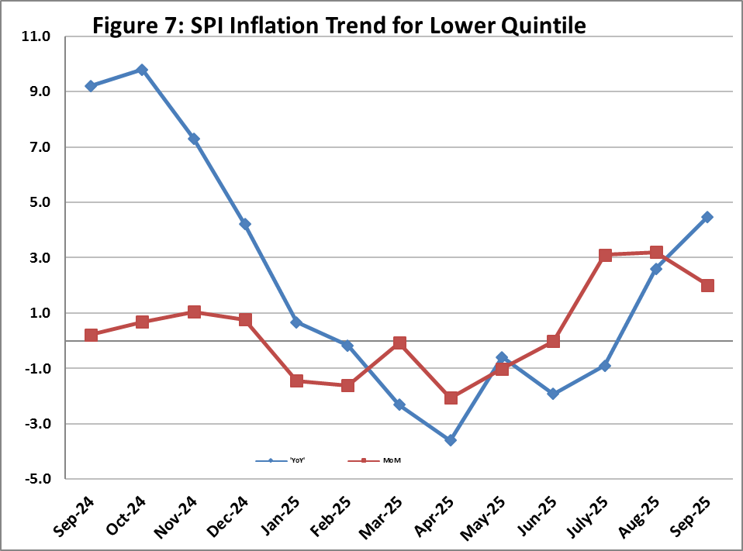

**V. Wholesale Price Index**

The Wholesale Price Index for **September 2025** increased by **0.53%** over **August 2025** and increased by **0.59%** over the corresponding month of the last year i.e. **September, 2024**. YoY and MoM movements from September, 2024 to September, 2025 are also graphed below in Figure 8.

|  |  |  |  |  |  |  |  |  |  |  |
| --- | --- | --- | --- | --- | --- | --- | --- | --- | --- | --- |
| Table 5: Wholesale Price Index by Group of Commodities (Base 2015-16) | | | | | | | | | | |
| No | Group | Group  Weight  (%) | Indices | | | % Change  Sep 2025  Over | | Impact  (In % points)  Sep 2025 Over | |
| Sep 25 | Aug 25 | Sep 24 | Aug 25 | Sep 24 | Aug 25 | Sep 24 |
|  | General | 100.00 | **315.34** | **313.68** | **313.50** | **0.53** | **0.59** | **0.53** | **0.59** |
| 1 | Agriculture Forestry & Fishery | 25.77 | 283.50 | 278.18 | 288.28 | 1.91 | -1.66 | 0.44 | -0.39 |
| 2 | Ores/Minerals, Elec., Gas & Water | 12.01 | 349.10 | 352.31 | 367.37 | -0.91 | -4.97 | -0.12 | -0.70 |
| 3 | Food, Beverages, Tobacco, Textiles & Leather Products | 31.11 | 290.38 | 284.96 | 271.44 | 1.90 | 6.98 | 0.54 | 1.88 |
|  | i. Food Products, Beverages & Tobacco | 20.07 | 310.15 | 301.25 | 284.80 | 2.95 | 8.90 | 0.57 | 1.62 |
|  | ii. Textiles & Apparels | 10.33 | 259.63 | 260.63 | 251.17 | -0.38 | 3.37 | -0.03 | 0.28 |
|  | iii. Leather Products | 0.71 | 179.03 | 178.56 | 188.92 | 0.26 | -5.24 | 0.00 | -0.02 |
| 4 | Other Transportable Goods | 22.40 | 338.00 | 342.32 | 342.57 | -1.26 | -1.33 | -0.31 | -0.33 |
| 5 | Metal Product, Machinery & Equipment | 8.72 | 393.89 | 394.27 | 389.29 | -0.10 | 1.18 | -0.01 | 0.13 |

Main contributors to month-on-month and year-on-year percentage changes are given below and detail is given in **Annexure-C**.

1. **MONTH-ON-MONTH:** **Top few commodities which varied from previous month are given below:**

**Increased:** Wheat (36.94%), Wheat Flour (28.50%), Vegetables (27.54%), Maize (11.02%), Dry Fruits (7.68%), Oil Cakes (4.90%), Eggs (4.76%), Other Oil Seeds (4.52%), Edible Roots / Potatoes (4.20%), Rice (3.36%), Meat of Animals (2.01%) and Medicines (1.92%).

**Decreased:** Poultry (7.54%), Furnace Oil (4.17%), Fibre Crops (4.13%), Other Fabrics (3.07%), Electrical Energy (3.02%), Diesel Oil (2.88%), Kerosene Oil (1.91%) and Stimulant & Spice Crops (1.15%).

**YEAR-ON-YEAR: Top few commodities which varied from previous year are given below:**

**Increased:** Other Food Products (52.95%), Sugar Confectionary (33.18%), Sorghum / Jowar (31.11%), Sugar Refined (28.18%), Raw Animal Materials / Wool (27.07%), Millet / Bajra (26.99%), Dyeing Material (22.99%), Wheat (19.62%), Dry Fruits (19.59%) and Fresh Fruits (18.03%).

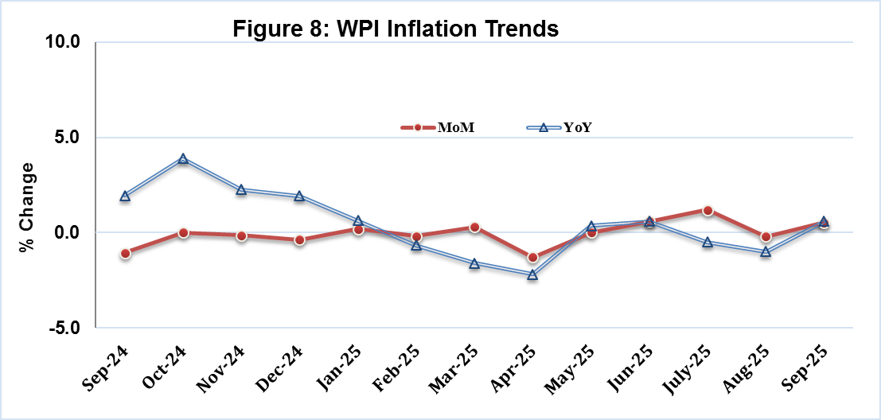**Decreased:** Other Cereal Flour (21.64%), Electrical Energy (20.11%), Furnace Oil (19.01%), Fibre Crops (15.60%), Stimulant & Spice Crops (15.53%), Edible Roots / Potatoes (14.53%), Pulses (14.21%) and Steel Bar & Sheets (8.48%).

| **Annexure A: CPI (Urban) Index Numbers by Commodity Groups & Commodities (2015-16=100)** | | | | | | | | | | | |
| --- | --- | --- | --- | --- | --- | --- | --- | --- | --- | --- | --- |
| Item and Specification | | Weight | Index Numbers  Sep 25 Aug 25 Sep 24 | | | % Change in Sep 2025 over  Aug 2025 Sep 2024 | | | | | |
|  | ***General*** | ***100.0000*** | ***272.09*** | ***268.06*** | ***257.92*** |  | ***+*** | ***1.50*** |  | ***+*** | ***5.49*** |
|  | ***Food and non-alcoholic Beverages*** | ***30.4215*** | ***287.74*** | ***274.75*** | ***276.17*** |  | ***+*** | ***4.73*** |  | ***+*** | ***4.19*** |
| 01 | Wheat | 0.6120 | 260.50 | 189.35 | 221.66 |  | + | 37.58 |  | + | 17.52 |
| 02 | Wheat flour | 3.0075 | 260.69 | 193.92 | 229.63 |  | + | 34.43 |  | + | 13.53 |
| 03 | Wheat products | 0.0936 | 280.38 | 262.39 | 293.10 |  | + | 6.86 |  | - | 4.34 |
| 04 | Besan | 0.0830 | 254.06 | 251.59 | 313.38 |  | + | 0.98 |  | - | 18.93 |
| 05 | Rice | 1.1804 | 330.09 | 321.76 | 315.60 |  | + | 2.59 |  | + | 4.59 |
| 06 | Bakery and confectionary | 0.4770 | 270.74 | 269.45 | 260.22 |  | + | 0.48 |  | + | 4.04 |
| 07 | Nimco | 0.1224 | 301.17 | 300.77 | 289.86 |  | + | 0.13 |  | + | 3.90 |
| 08 | Meat | 2.0411 | 348.63 | 345.89 | 320.44 |  | + | 0.79 |  | + | 8.80 |
| 09 | Chicken | 1.3631 | 292.98 | 309.48 | 309.90 |  | - | 5.33 |  | - | 5.46 |
| 10 | Fish | 0.3855 | 211.35 | 210.99 | 196.82 |  | + | 0.17 |  | + | 7.38 |
| 11 | Milk fresh | 7.1070 | 266.65 | 265.95 | 259.28 |  | + | 0.26 |  | + | 2.84 |
| 12 | Milk products | 0.6407 | 268.56 | 268.22 | 263.84 |  | + | 0.13 |  | + | 1.79 |
| 13 | Milk powder | 0.3106 | 317.55 | 317.07 | 302.15 |  | + | 0.15 |  | + | 5.10 |
| 14 | Eggs | 0.5083 | 361.49 | 345.94 | 352.44 |  | + | 4.49 |  | + | 2.57 |
| 15 | Butter | 0.0932 | 477.26 | 460.89 | 375.71 |  | + | 3.55 |  | + | 27.03 |
| 16 | Mustard oil | 0.0120 | 310.45 | 308.24 | 284.82 |  | + | 0.72 |  | + | 9.00 |
| 17 | Cooking oil | 1.1016 | 324.71 | 324.73 | 298.40 |  | - | 0.01 |  | + | 8.82 |
| 18 | Vegetable ghee | 1.0324 | 343.87 | 343.22 | 310.52 |  | + | 0.19 |  | + | 10.74 |
| 19 | Dry fruits | 0.3299 | 298.95 | 298.48 | 284.29 |  | + | 0.16 |  | + | 5.16 |
| 20 | Fresh fruits | 1.4363 | 220.51 | 218.50 | 204.03 |  | + | 0.92 |  | + | 8.08 |
| 21 | Pulse masoor | 0.1624 | 200.35 | 200.28 | 212.36 |  | + | 0.03 |  | - | 5.66 |
| 22 | Pulse moong | 0.1697 | 237.88 | 238.41 | 207.35 |  | - | 0.22 |  | + | 14.72 |
| 23 | Pulse mash | 0.1152 | 185.78 | 187.97 | 243.67 |  | - | 1.17 |  | - | 23.76 |
| 24 | Pulse gram | 0.1660 | 251.67 | 248.07 | 321.62 |  | + | 1.45 |  | - | 21.75 |
| 25 | Gram whole | 0.0912 | 269.69 | 270.77 | 316.86 |  | - | 0.40 |  | - | 14.89 |
| 26 | Beans | 0.0408 | 364.08 | 366.50 | 375.02 |  | - | 0.66 |  | - | 2.92 |
| 27 | Potatoes | 0.4496 | 342.66 | 324.13 | 400.25 |  | + | 5.72 |  | - | 14.39 |
| 28 | Onions | 0.5928 | 206.52 | 160.74 | 344.14 |  | + | 28.48 |  | - | 39.99 |
| 29 | Tomatoes | 0.3459 | 405.76 | 245.86 | 272.81 |  | + | 65.04 |  | + | 48.73 |
| 30 | Fresh vegetables | 1.5306 | 277.11 | 254.16 | 281.48 |  | + | 9.03 |  | - | 1.55 |
| 31 | Sugar | 1.1130 | 293.97 | 286.12 | 228.78 |  | + | 2.74 |  | + | 28.49 |
| 32 | Gur | 0.0379 | 277.53 | 273.43 | 241.93 |  | + | 1.50 |  | + | 14.72 |
| 33 | Honey | 0.1017 | 222.73 | 222.69 | 188.88 |  | + | 0.02 |  | + | 17.92 |
| 34 | Sweetmeat | 0.3535 | 332.76 | 331.14 | 306.04 |  | + | 0.49 |  | + | 8.73 |
| 35 | Ice cream | 0.1044 | 199.68 | 199.68 | 199.33 |  | + | 0.00 |  | + | 0.18 |
| 36 | Condiments and Spices | 1.3340 | 373.17 | 372.15 | 334.78 |  | + | 0.27 |  | + | 11.47 |
| 37 | Dessert preparation | 0.0419 | 297.93 | 297.85 | 262.75 |  | + | 0.03 |  | + | 13.39 |
| 38 | Tea | 0.8427 | 273.67 | 273.67 | 332.73 |  | + | 0.00 |  | - | 17.75 |
| 39 | Beverages | 0.8906 | 261.09 | 261.06 | 250.98 |  | + | 0.01 |  | + | 4.03 |
|  | ***Alcoholic Beverages, Tobacco*** | ***0.8540*** | ***420.57*** | ***420.23*** | ***407.83*** |  | ***+*** | ***0.08*** |  | ***+*** | ***3.12*** |
| 40 | Cigarettes | 0.7167 | 411.79 | 411.55 | 406.04 |  | + | 0.06 |  | + | 1.42 |
| 41 | Pan prepared | 0.1373 | 466.38 | 465.58 | 417.17 |  | + | 0.17 |  | + | 11.80 |
|  | ***Clothing and footwear*** | ***8.0096*** | ***255.85*** | ***255.32*** | ***237.02*** |  | ***+*** | ***0.21*** |  | ***+*** | ***7.94*** |
| 42 | Cotton cloth | 2.2227 | 299.83 | 298.53 | 279.95 |  | + | 0.44 |  | + | 7.10 |
| 43 | Woollen cloth | 0.8361 | 243.92 | 243.55 | 228.49 |  | + | 0.15 |  | + | 6.75 |
| 44 | Readymade garments | 1.3196 | 223.24 | 222.92 | 206.45 |  | + | 0.14 |  | + | 8.13 |
| 45 | Woollen readymade garments | 0.4307 | 256.71 | 256.71 | 230.68 |  | + | 0.00 |  | + | 11.28 |
| 46 | Tailoring | 1.0741 | 238.22 | 237.76 | 227.84 |  | + | 0.19 |  | + | 4.56 |
| 47 | Hosiery | 0.4070 | 239.53 | 239.41 | 226.83 |  | + | 0.05 |  | + | 5.60 |
| 48 | Dupatta | 0.1713 | 205.48 | 205.28 | 195.46 |  | + | 0.10 |  | + | 5.13 |
| 49 | Cleaning and laundering | 0.0665 | 276.51 | 276.51 | 260.52 |  | + | 0.00 |  | + | 6.14 |
| 50 | Footwear | 1.4816 | 247.57 | 247.53 | 219.70 |  | + | 0.02 |  | + | 12.69 |
|  | ***Housing, water, Elec., Gas and other Fuels*** | ***27.0332*** | ***254.08*** | ***255.60*** | ***241.96*** |  | ***-*** | ***0.59*** |  | ***+*** | ***5.01*** |
| 51 | House rent | 19.2558 | 172.97 | 172.97 | 164.08 |  | + | 0.00 |  | + | 5.42 |
| 52 | Construction input items | 0.3765 | 269.90 | 268.48 | 267.19 |  | + | 0.53 |  | + | 1.01 |
| 53 | Construction wage rates | 0.2025 | 228.36 | 227.64 | 217.12 |  | + | 0.32 |  | + | 5.18 |
| 54 | Water supply | 0.5269 | 230.44 | 230.44 | 204.19 |  | + | 0.00 |  | + | 12.86 |
| 55 | Garbage collection | 0.1064 | 265.81 | 265.81 | 252.22 |  | + | 0.00 |  | + | 5.39 |
| 56 | Electricity charges | 4.5562 | 224.65 | 235.48 | 275.67 |  | - | 4.60 |  | - | 18.51 |
| 57 | Gas charges | 1.0807 | 1817.96 | 1817.96 | 1479.08 |  | + | 0.00 |  | + | 22.91 |
| 58 | Liquefied Hydrocarbons | 0.5064 | 308.77 | 295.37 | 319.38 |  | + | 4.54 |  | - | 3.32 |
| 59 | Solid Fuel | 0.4218 | 226.86 | 225.46 | 204.59 |  | + | 0.62 |  | + | 10.89 |
|  | ***Furnishing and household equipments*** | ***4.0937*** | ***270.65*** | ***269.71*** | ***258.43*** |  | ***+*** | ***0.35*** |  | ***+*** | ***4.73*** |
| 60 | Furniture and furnishing | 0.4750 | 263.17 | 262.63 | 248.64 |  | + | 0.21 |  | + | 5.84 |
| 61 | Carpets | 0.0308 | 154.28 | 154.14 | 149.43 |  | + | 0.09 |  | + | 3.25 |
| 62 | Household textiles | 0.3420 | 212.08 | 210.31 | 186.36 |  | + | 0.84 |  | + | 13.80 |
| 63 | Household equipments | 1.0032 | 274.22 | 273.66 | 255.31 |  | + | 0.20 |  | + | 7.41 |
| 64 | Plastic products | 0.0536 | 233.65 | 233.56 | 214.40 |  | + | 0.04 |  | + | 8.98 |
| 65 | Major tools & equipments | 0.0084 | 251.70 | 251.27 | 232.96 |  | + | 0.17 |  | + | 8.04 |
| 66 | Washing soap/detergents/match | 1.4112 | 323.90 | 322.82 | 321.98 |  | + | 0.33 |  | + | 0.60 |
| 67 | Household servant | 0.7695 | 206.41 | 205.26 | 191.76 |  | + | 0.56 |  | + | 7.64 |
|  | ***Health*** | ***2.3098*** | ***280.61*** | ***278.71*** | ***257.52*** |  | ***+*** | ***0.68*** |  | ***+*** | ***8.97*** |
| 68 | Drugs and medicines | 1.0735 | 301.47 | 298.59 | 273.52 |  | + | 0.96 |  | + | 10.22 |
| 69 | Therapeutic Appliances and Equipments | 0.0054 | 155.97 | 155.67 | 150.84 |  | + | 0.19 |  | + | 3.40 |
| 70 | Doctor (MBBS) clinic fee | 0.4044 | 353.04 | 351.91 | 326.91 |  | + | 0.32 |  | + | 7.99 |
| 71 | Dental services | 0.0156 | 231.05 | 230.24 | 212.92 |  | + | 0.35 |  | + | 8.51 |
| 72 | Medical tests | 0.2367 | 217.37 | 215.91 | 195.41 |  | + | 0.68 |  | + | 11.24 |
| 73 | Hospitals services | 0.5742 | 219.20 | 218.35 | 206.58 |  | + | 0.39 |  | + | 6.11 |
|  | ***Transport*** | ***6.1368*** | ***311.84*** | ***312.80*** | ***299.64*** |  | ***-*** | ***0.31*** |  | ***+*** | ***4.07*** |
| 74 | Motor vehicles | 0.8097 | 267.42 | 267.19 | 259.34 |  | + | 0.09 |  | + | 3.12 |
| 75 | Motor vehicle accessories | 0.1941 | 266.36 | 265.92 | 259.99 |  | + | 0.17 |  | + | 2.45 |
| 76 | Motor fuel | 2.9088 | 360.42 | 360.20 | 347.75 |  | + | 0.06 |  | + | 3.64 |
| 77 | Mechanical services | 0.4290 | 239.15 | 238.72 | 225.49 |  | + | 0.18 |  | + | 6.06 |
| 78 | Motor vehicle tax | 0.0482 | 399.23 | 399.23 | 399.23 |  | + | 0.00 |  | + | 0.00 |
| 79 | Transport services | 1.7470 | 272.03 | 276.04 | 258.09 |  | - | 1.45 |  | + | 5.40 |
|  | ***Communication*** | ***2.3536*** | ***138.78*** | ***138.68*** | ***138.34*** |  | ***+*** | ***0.07*** |  | ***+*** | ***0.32*** |
| 80 | Postal services | 0.0190 | 224.60 | 221.59 | 214.41 |  | + | 1.36 |  | + | 4.75 |
| 81 | Communication apparatus | 0.4524 | 190.24 | 189.85 | 188.35 |  | + | 0.21 |  | + | 1.00 |
| 82 | Communication Services | 1.8822 | 125.55 | 125.55 | 125.55 |  | + | 0.00 |  | + | 0.00 |
|  | ***Recreation and culture*** | ***1.7301*** | ***250.70*** | ***251.61*** | ***259.42*** |  | ***-*** | ***0.36*** |  | ***-*** | ***3.36*** |
| 83 | Recreation and culture | 0.6478 | 155.07 | 155.07 | 152.80 |  | + | 0.00 |  | + | 1.49 |
| 84 | Text books | 0.6655 | 303.56 | 306.66 | 332.57 |  | - | 1.01 |  | - | 8.72 |
| 85 | Newspapers | 0.0716 | 242.82 | 242.82 | 216.94 |  | + | 0.00 |  | + | 11.93 |
| 86 | stationery | 0.3452 | 329.89 | 328.45 | 327.30 |  | + | 0.44 |  | + | 0.79 |
|  | ***Education*** | ***4.8807*** | ***216.28*** | ***216.13*** | ***195.66*** |  | ***+*** | ***0.07*** |  | ***+*** | ***10.54*** |
| 87 | Education | 4.8807 | 216.28 | 216.13 | 195.66 |  | + | 0.07 |  | + | 10.54 |
|  | ***Restaurants and hotels*** | ***7.4050*** | ***286.84*** | ***284.54*** | ***271.99*** |  | ***+*** | ***0.81*** |  | ***+*** | ***5.46*** |
| 88 | Readymade food | 5.5235 | 294.01 | 291.51 | 278.58 |  | + | 0.86 |  | + | 5.54 |
| 89 | Marriage Hall Charges | 1.7514 | 272.07 | 270.21 | 258.89 |  | + | 0.69 |  | + | 5.09 |
| 90 | Accommodation Services | 0.1301 | 181.46 | 181.32 | 168.39 |  | + | 0.08 |  | + | 7.76 |
|  | ***Misc. goods and services*** | ***4.7720*** | ***328.68*** | ***323.39*** | ***286.58*** |  | ***+*** | ***1.64*** |  | ***+*** | ***14.69*** |
| 91 | Personal Grooming Services | 0.8001 | 272.47 | 272.28 | 250.88 |  | + | 0.07 |  | + | 8.61 |
| 92 | Electrical Appliances for Per | 0.0465 | 190.99 | 190.81 | 167.19 |  | + | 0.09 |  | + | 14.24 |
| 93 | Appliances/Articles/Products | 2.9807 | 286.20 | 284.81 | 264.66 |  | + | 0.49 |  | + | 8.14 |
| 94 | Personal Effects n.e.c. | 0.9447 | 517.10 | 494.93 | 391.85 |  | + | 4.48 |  | + | 31.96 |

| **Annexure B: CPI (Rural) Index Numbers by Commodity Groups & Commodities (2015-16=100)** | | | | | | | | | | | |
| --- | --- | --- | --- | --- | --- | --- | --- | --- | --- | --- | --- |
| Item and Specification | | Weight | Index Numbers  Sep 25 Aug 25 Sep 24 | | | % Change in Sep 2025 over  Aug 2025 Sep 2024 | | | | | |
|  | ***General*** | ***100.0000*** | ***280.91*** | ***273.37*** | ***265.55*** |  | ***+*** | ***2.76*** |  | ***+*** | ***5.78*** |
|  | ***Food and non-alcoholic Beverages*** | ***40.8668*** | ***294.12*** | ***276.77*** | ***277.61*** |  | ***+*** | ***6.27*** |  | ***+*** | ***5.95*** |
| 01 | Wheat | 3.4736 | 269.83 | 199.14 | 227.61 |  | + | 35.50 |  | + | 18.55 |
| 02 | Wheat Flour | 3.4297 | 269.89 | 200.77 | 228.06 |  | + | 34.43 |  | + | 18.34 |
| 03 | Wheat Products | 0.1068 | 283.28 | 262.60 | 290.35 |  | + | 7.88 |  | - | 2.43 |
| 04 | Besan | 0.0728 | 273.04 | 271.37 | 312.22 |  | + | 0.62 |  | - | 12.55 |
| 05 | Rice | 1.5501 | 425.55 | 419.78 | 419.38 |  | + | 1.37 |  | + | 1.47 |
| 06 | Bakery and Confectionary | 0.3702 | 315.81 | 313.81 | 303.55 |  | + | 0.64 |  | + | 4.04 |
| 07 | Nimco | 0.0774 | 305.77 | 303.32 | 301.85 |  | + | 0.81 |  | + | 1.30 |
| 08 | Meat | 1.7146 | 373.08 | 369.76 | 332.09 |  | + | 0.90 |  | + | 12.34 |
| 09 | Chicken | 1.4641 | 318.11 | 323.31 | 323.70 |  | - | 1.61 |  | - | 1.73 |
| 10 | Fish | 0.2640 | 225.39 | 224.82 | 209.37 |  | + | 0.25 |  | + | 7.65 |
| 11 | Milk fresh | 10.3803 | 266.65 | 266.26 | 253.88 |  | + | 0.15 |  | + | 5.03 |
| 12 | Milk products | 0.9624 | 263.17 | 263.17 | 254.57 |  | + | 0.00 |  | + | 3.38 |
| 13 | Milk powder | 0.1062 | 288.95 | 289.96 | 275.08 |  | - | 0.35 |  | + | 5.04 |
| 14 | Eggs | 0.5665 | 341.34 | 330.10 | 338.54 |  | + | 3.41 |  | + | 0.83 |
| 15 | Butter | 0.3333 | 313.67 | 311.00 | 285.62 |  | + | 0.86 |  | + | 9.82 |
| 16 | Mustard oil | 0.0136 | 326.00 | 322.36 | 305.22 |  | + | 1.13 |  | + | 6.81 |
| 17 | Cooking oil | 0.6011 | 362.86 | 361.82 | 324.62 |  | + | 0.29 |  | + | 11.78 |
| 18 | Vegetable ghee | 2.3764 | 374.58 | 374.77 | 334.87 |  | - | 0.05 |  | + | 11.86 |
| 19 | Dry fruits | 0.2496 | 367.55 | 364.14 | 325.27 |  | + | 0.94 |  | + | 13.00 |
| 20 | Fresh fruits | 1.4505 | 229.29 | 237.41 | 212.82 |  | - | 3.42 |  | + | 7.74 |
| 21 | Pulse Masoor | 0.2076 | 225.71 | 225.67 | 238.06 |  | + | 0.02 |  | - | 5.19 |
| 22 | Pulse Moong | 0.2510 | 261.36 | 254.18 | 228.60 |  | + | 2.82 |  | + | 14.33 |
| 23 | Pulse Mash | 0.1465 | 197.11 | 200.68 | 254.18 |  | - | 1.78 |  | - | 22.45 |
| 24 | Pulse Gram | 0.2751 | 259.38 | 258.80 | 314.48 |  | + | 0.22 |  | - | 17.52 |
| 25 | Gram Whole | 0.1116 | 292.04 | 295.03 | 314.69 |  | - | 1.01 |  | - | 7.20 |
| 26 | Beans | 0.0896 | 397.29 | 400.44 | 405.32 |  | - | 0.79 |  | - | 1.98 |
| 27 | Potatoes | 0.7437 | 374.54 | 360.65 | 442.91 |  | + | 3.85 |  | - | 15.44 |
| 28 | Onions | 0.8965 | 195.93 | 152.93 | 346.50 |  | + | 28.12 |  | - | 43.45 |
| 29 | Tomatoes | 0.5069 | 430.77 | 227.67 | 247.16 |  | + | 89.21 |  | + | 74.29 |
| 30 | Fresh Vegetables | 2.0947 | 277.11 | 252.24 | 263.60 |  | + | 9.86 |  | + | 5.13 |
| 31 | Sugar | 2.0296 | 300.83 | 295.32 | 230.18 |  | + | 1.87 |  | + | 30.69 |
| 32 | Gur | 0.1522 | 289.02 | 277.87 | 252.36 |  | + | 4.01 |  | + | 14.53 |
| 33 | Honey | 0.0296 | 230.07 | 230.07 | 192.44 |  | + | 0.00 |  | + | 19.55 |
| 34 | Sweetmeat | 0.3967 | 294.30 | 294.30 | 281.10 |  | + | 0.00 |  | + | 4.70 |
| 35 | Ice Cream | 0.0568 | 199.76 | 199.76 | 199.34 |  | + | 0.00 |  | + | 0.21 |
| 36 | Condiments and Spices | 1.4919 | 297.35 | 299.23 | 296.32 |  | - | 0.63 |  | + | 0.35 |
| 37 | Dessert Preparation | 0.0133 | 292.45 | 288.87 | 268.52 |  | + | 1.24 |  | + | 8.91 |
| 38 | Tea | 1.2566 | 273.01 | 273.01 | 333.85 |  | + | 0.00 |  | - | 18.22 |
| 39 | Beverages | 0.5537 | 253.91 | 253.54 | 241.72 |  | + | 0.15 |  | + | 5.04 |
|  | ***Alcoholic Beverages, Tobacco*** | ***1.2786*** | ***375.81*** | ***375.17*** | ***362.46*** |  | ***+*** | ***0.17*** |  | ***+*** | ***3.68*** |
| 40 | Cigarettes | 1.2364 | 375.70 | 375.17 | 363.01 |  | + | 0.14 |  | + | 3.50 |
| 41 | Pan Prepared | 0.0422 | 379.08 | 375.27 | 346.31 |  | + | 1.02 |  | + | 9.46 |
|  | ***Clothing and footwear*** | ***9.4826*** | ***278.46*** | ***276.67*** | ***257.69*** |  | ***+*** | ***0.65*** |  | ***+*** | ***8.06*** |
| 42 | Cotton Cloth | 2.8381 | 305.70 | 304.32 | 291.15 |  | + | 0.45 |  | + | 5.00 |
| 43 | Woollen Cloth | 1.0959 | 269.54 | 264.16 | 249.61 |  | + | 2.04 |  | + | 7.98 |
| 44 | Readymade Garments | 1.1345 | 258.67 | 255.84 | 226.43 |  | + | 1.11 |  | + | 14.24 |
| 45 | Woollen Readymade Garments | 0.5401 | 309.66 | 309.66 | 268.35 |  | + | 0.00 |  | + | 15.39 |
| 46 | Tailoring | 1.2999 | 260.89 | 260.89 | 239.56 |  | + | 0.00 |  | + | 8.90 |
| 47 | Hosiery | 0.4322 | 350.64 | 350.64 | 338.52 |  | + | 0.00 |  | + | 3.58 |
| 48 | Dupatta | 0.2078 | 255.32 | 254.08 | 239.09 |  | + | 0.49 |  | + | 6.79 |
| 49 | Cleaning and Laundering | 0.0176 | 264.16 | 261.25 | 251.35 |  | + | 1.11 |  | + | 5.10 |
| 50 | Footwear | 1.9165 | 244.46 | 242.54 | 224.39 |  | + | 0.79 |  | + | 8.94 |
|  | ***Housing, water, Elec., Gas and other Fuels*** | ***18.4853*** | ***222.12*** | ***223.19*** | ***221.31*** |  | ***-*** | ***0.48*** |  | ***+*** | ***0.37*** |
| 51 | House Rent | 8.6110 | 181.11 | 181.11 | 170.84 |  | + | 0.00 |  | + | 6.01 |
| 52 | Construction Input Items | 0.6306 | 258.37 | 255.45 | 252.66 |  | + | 1.14 |  | + | 2.26 |
| 53 | Construction Wage Rates | 0.2526 | 245.93 | 245.28 | 236.16 |  | + | 0.27 |  | + | 4.14 |
| 54 | Water Supply | 0.0645 | 325.72 | 325.72 | 307.79 |  | + | 0.00 |  | + | 5.83 |
| 55 | Garbage Collection | 0.0080 | 204.36 | 204.36 | 190.06 |  | + | 0.00 |  | + | 7.52 |
| 56 | Electricity Charges | 3.4431 | 224.65 | 235.48 | 275.67 |  | - | 4.60 |  | - | 18.51 |
| 57 | Liquefied Hydrocarbons | 0.9994 | 294.65 | 286.79 | 297.49 |  | + | 2.74 |  | - | 0.95 |
| 58 | Solid Fuel | 4.4761 | 274.95 | 273.24 | 253.13 |  | + | 0.63 |  | + | 8.62 |
|  | ***Furnishing and household equipments*** | ***4.1031*** | ***295.37*** | ***294.70*** | ***285.87*** |  | ***+*** | ***0.23*** |  | ***+*** | ***3.32*** |
| 59 | Furniture and Furnishing | 0.5786 | 295.19 | 292.32 | 273.78 |  | + | 0.98 |  | + | 7.82 |
| 60 | Household Textiles | 0.4382 | 244.14 | 242.11 | 223.81 |  | + | 0.84 |  | + | 9.08 |
| 61 | Household Equipments | 1.2774 | 296.62 | 295.51 | 282.64 |  | + | 0.38 |  | + | 4.95 |
| 62 | Plastic Products | 0.0776 | 306.39 | 302.56 | 279.48 |  | + | 1.27 |  | + | 9.63 |
| 63 | Major Tools and Equipments | 0.0324 | 247.13 | 247.13 | 229.71 |  | + | 0.00 |  | + | 7.58 |
| 64 | Washing Soaps, Detergents and | 1.6989 | 308.11 | 309.02 | 309.78 |  | - | 0.29 |  | - | 0.54 |
|  | ***Health*** | ***3.5141*** | ***278.38*** | ***275.70*** | ***247.99*** |  | ***+*** | ***0.97*** |  | ***+*** | ***12.25*** |
| 65 | Drugs and Medicines | 1.5792 | 327.21 | 324.57 | 287.92 |  | + | 0.81 |  | + | 13.65 |
| 66 | Doctor Clinic Fee | 0.5128 | 329.20 | 327.80 | 288.00 |  | + | 0.43 |  | + | 14.31 |
| 67 | Dental Services | 0.0181 | 254.82 | 253.02 | 202.29 |  | + | 0.71 |  | + | 25.97 |
| 68 | Medical Tests | 0.3967 | 235.99 | 234.32 | 219.36 |  | + | 0.71 |  | + | 7.58 |
| 69 | Hospitals Services | 1.0073 | 193.08 | 189.28 | 177.11 |  | + | 2.01 |  | + | 9.02 |
|  | ***Transport*** | ***5.5580*** | ***325.74*** | ***326.48*** | ***312.01*** |  | ***-*** | ***0.23*** |  | ***+*** | ***4.40*** |
| 70 | Motor Vehicles | 0.7305 | 194.75 | 194.73 | 193.12 |  | + | 0.01 |  | + | 0.84 |
| 71 | Motor Vehicles Accessories | 0.1572 | 273.35 | 272.28 | 268.22 |  | + | 0.39 |  | + | 1.91 |
| 72 | Motor Fuels | 2.4932 | 362.20 | 362.05 | 348.67 |  | + | 0.04 |  | + | 3.88 |
| 73 | Mechanical Services | 0.3645 | 232.83 | 232.83 | 229.57 |  | + | 0.00 |  | + | 1.42 |
| 74 | Motor Vehicle Tax | 0.0174 | 342.03 | 342.03 | 342.03 |  | + | 0.00 |  | + | 0.00 |
| 75 | Transport Services | 1.7952 | 351.72 | 354.30 | 329.76 |  | - | 0.73 |  | + | 6.66 |
|  | ***Communication*** | ***1.9940*** | ***129.33*** | ***129.31*** | ***128.57*** |  | ***+*** | ***0.02*** |  | ***+*** | ***0.59*** |
| 76 | Postal Services | 0.0070 | 181.92 | 179.32 | 179.32 |  | + | 1.45 |  | + | 1.45 |
| 77 | Communication Apparatus | 0.3362 | 165.43 | 165.35 | 160.95 |  | + | 0.05 |  | + | 2.78 |
| 78 | Communication Services | 1.6508 | 121.76 | 121.76 | 121.76 |  | + | 0.00 |  | + | 0.00 |
|  | ***Recreation and culture*** | ***1.3764*** | ***296.47*** | ***297.17*** | ***301.16*** |  | ***-*** | ***0.24*** |  | ***-*** | ***1.56*** |
| 79 | Recreation and Culture | 0.4763 | 257.56 | 256.83 | 231.03 |  | + | 0.28 |  | + | 11.48 |
| 80 | Text Books | 0.5047 | 316.19 | 320.88 | 360.47 |  | - | 1.46 |  | - | 12.28 |
| 81 | Newspapers | 0.0230 | 282.94 | 250.36 | 242.52 |  | + | 13.01 |  | + | 16.67 |
| 82 | Stationery | 0.3724 | 320.33 | 319.53 | 314.08 |  | + | 0.25 |  | + | 1.99 |
|  | ***Education*** | ***2.1342*** | ***248.13*** | ***246.57*** | ***222.96*** |  | ***+*** | ***0.63*** |  | ***+*** | ***11.29*** |
| 83 | Education | 2.1342 | 248.13 | 246.57 | 222.96 |  | + | 0.63 |  | + | 11.29 |
|  | ***Restaurants and hotels*** | ***6.1895*** | ***302.60*** | ***301.25*** | ***282.10*** |  | ***+*** | ***0.45*** |  | ***+*** | ***7.27*** |
| 84 | Readymade Food | 3.8001 | 329.27 | 327.99 | 306.27 |  | + | 0.39 |  | + | 7.51 |
| 85 | Marriage Hall Charges | 2.2525 | 269.10 | 267.55 | 251.57 |  | + | 0.58 |  | + | 6.97 |
| 86 | Accommodation Services | 0.1369 | 113.40 | 113.40 | 113.40 |  | + | 0.00 |  | + | 0.00 |
|  | ***Misc. goods and services*** | ***5.0174*** | ***353.86*** | ***348.07*** | ***307.12*** |  | ***+*** | ***1.66*** |  | ***+*** | ***15.22*** |
| 87 | Personal Grooming Services | 1.5363 | 317.27 | 316.85 | 300.88 |  | + | 0.13 |  | + | 5.45 |
| 88 | Appliances/Articles/Products | 2.2746 | 267.88 | 267.29 | 253.89 |  | + | 0.22 |  | + | 5.51 |
| 89 | Personal Effects n.e.c. | 1.2065 | 562.56 | 540.14 | 415.43 |  | + | 4.15 |  | + | 35.42 |

| **Annexure C: Wholesale Price Indices by Major Groups & Commodities (2015-16=100)** | | | | | | | | | | | |
| --- | --- | --- | --- | --- | --- | --- | --- | --- | --- | --- | --- |
| Item and Specification | | Weight | Index Numbers  Sep 25 Aug 25 Sep 24 | | | % Change in Sep 2025 over  Aug 2025 Sep 2024 | | | | | |
|  | ***General*** | ***100.0000*** | ***315.34*** | ***313.68*** | ***313.50*** |  | ***+*** | ***0.53*** |  | ***+*** | ***0.59*** |
|  | ***Agriculture Forestry & Fishery*** | ***25.7674*** | ***283.50*** | ***278.18*** | ***288.28*** |  | ***+*** | ***1.91*** |  | ***-*** | ***1.66*** |
| 001 | Wheat | 0.6297 | 255.60 | 186.65 | 213.67 |  | + | 36.94 |  | + | 19.62 |
| 002 | Maize | 0.6764 | 298.19 | 268.60 | 277.09 |  | + | 11.02 |  | + | 7.61 |
| 003 | Rice | 2.4413 | 331.33 | 320.55 | 342.81 |  | + | 3.36 |  | - | 3.35 |
| 004 | Sorghum / Jowar | 0.0214 | 359.66 | 355.59 | 274.31 |  | + | 1.14 |  | + | 31.11 |
| 005 | Millet / Bajra | 0.0374 | 343.84 | 337.48 | 270.76 |  | + | 1.88 |  | + | 26.99 |
| 006 | Vegetables | 1.2441 | 395.75 | 310.30 | 392.19 |  | + | 27.54 |  | + | 0.91 |
| 007 | Fresh Fruits | 1.5144 | 269.56 | 268.85 | 228.38 |  | + | 0.26 |  | + | 18.03 |
| 008 | Dry Fruits | 0.2478 | 424.65 | 394.38 | 355.08 |  | + | 7.68 |  | + | 19.59 |
| 009 | Cotton Seeds | 1.1511 | 192.70 | 189.86 | 187.75 |  | + | 1.50 |  | + | 2.64 |
| 010 | Other Oil Seeds | 0.0722 | 295.38 | 282.61 | 278.62 |  | + | 4.52 |  | + | 6.02 |
| 011 | Edible Roots / Potatoes | 0.2540 | 416.90 | 400.08 | 487.80 |  | + | 4.20 |  | - | 14.53 |
| 012 | Stimulant & Spice Crops | 0.1634 | 411.95 | 416.76 | 487.71 |  | - | 1.15 |  | - | 15.53 |
| 013 | Pulses | 0.4901 | 262.47 | 264.68 | 305.95 |  | - | 0.83 |  | - | 14.21 |
| 014 | Sugar Crops | 1.0725 | 368.06 | 368.06 | 317.48 |  | + | 0.00 |  | + | 15.93 |
| 015 | Fibre Crops | 5.3169 | 297.23 | 310.05 | 352.17 |  | - | 4.13 |  | - | 15.60 |
| 016 | Unmanufactured Tobacco | 0.0742 | 554.55 | 551.17 | 616.70 |  | + | 0.61 |  | - | 10.08 |
| 017 | Poultry | 0.5633 | 275.40 | 297.87 | 298.96 |  | - | 7.54 |  | - | 7.88 |
| 018 | Raw Milk from Bovine Animals | 7.0279 | 254.61 | 254.46 | 245.34 |  | + | 0.06 |  | + | 3.78 |
| 019 | Eggs | 0.5034 | 363.93 | 347.40 | 351.01 |  | + | 4.76 |  | + | 3.68 |
| 020 | Raw Animal Materials / Wool | 0.0351 | 257.31 | 257.31 | 202.50 |  | + | 0.00 |  | + | 27.07 |
| 021 | Hides, Skins & Fur Skins, Raw | 0.4834 | 59.44 | 59.44 | 54.89 |  | + | 0.00 |  | + | 8.29 |
| 022 | Fuel Wood in Logs | 0.0179 | 215.22 | 215.00 | 184.13 |  | + | 0.10 |  | + | 16.88 |
| 023 | Fish Live Fresh or Chilled | 1.7295 | 217.71 | 219.65 | 217.84 |  | - | 0.88 |  | - | 0.06 |
|  | ***Ores/Minerals, Elec., Gas & Water*** | ***12.0069*** | ***349.10*** | ***352.31*** | ***367.37*** |  | ***-*** | ***0.91*** |  | ***-*** | ***4.97*** |
| 024 | Coal not Agglomerated | 0.7508 | 219.17 | 219.17 | 227.51 |  | + | 0.00 |  | - | 3.67 |
| 025 | Natural Gas Liquefied | 5.7065 | 444.79 | 443.56 | 417.71 |  | + | 0.28 |  | + | 6.48 |
| 026 | Salt & Pure Sodium Chloride | 0.0584 | 421.76 | 422.36 | 405.13 |  | - | 0.14 |  | + | 4.10 |
| 027 | Electrical Energy | 5.4912 | 266.65 | 274.95 | 333.78 |  | - | 3.02 |  | - | 20.11 |
|  | ***Food,Beverages,Tobacco,Textile*** | ***31.1122*** | ***290.38*** | ***284.96*** | ***271.44*** |  | ***+*** | ***1.90*** |  | ***+*** | ***6.98*** |
|  | ***Food Products, Beverages & Tobacco*** | ***20.0718*** | ***310.15*** | ***301.25*** | ***284.80*** |  | ***+*** | ***2.95*** |  | ***+*** | ***8.90*** |
| 028 | Meat of Animals | 3.4559 | 347.69 | 340.84 | 309.59 |  | + | 2.01 |  | + | 12.31 |
| 029 | Vegetables & Fruit Juice | 0.0058 | 252.95 | 253.05 | 239.89 |  | - | 0.04 |  | + | 5.44 |
| 030 | Dried Fruits & Nuts | 0.1733 | 400.81 | 394.23 | 380.57 |  | + | 1.67 |  | + | 5.32 |
| 031 | Fruit Juices | 0.3880 | 283.70 | 282.73 | 270.73 |  | + | 0.34 |  | + | 4.79 |
| 032 | Vegetable Oils Refined | 1.9242 | 290.25 | 289.59 | 270.48 |  | + | 0.23 |  | + | 7.31 |
| 033 | Vegetable Ghee | 1.5632 | 363.68 | 363.79 | 320.09 |  | - | 0.03 |  | + | 13.62 |
| 034 | Oil Cakes | 0.9611 | 249.76 | 238.09 | 260.43 |  | + | 4.90 |  | - | 4.10 |
| 035 | Processed Liquid Milk | 4.4437 | 332.40 | 331.48 | 318.61 |  | + | 0.28 |  | + | 4.33 |
| 036 | Milk & Cream in Solid Form | 0.0316 | 303.46 | 303.46 | 294.97 |  | + | 0.00 |  | + | 2.88 |
| 037 | Ice Cream | 0.0047 | 200.56 | 200.56 | 200.56 |  | + | 0.00 |  | + | 0.00 |
| 038 | Dairy Products N.E.C | 0.0117 | 335.07 | 334.90 | 324.81 |  | + | 0.05 |  | + | 3.16 |
| 039 | Wheat Flour | 2.3034 | 258.09 | 200.85 | 229.79 |  | + | 28.50 |  | + | 12.32 |
| 040 | Other Cereal Flour | 0.0604 | 272.21 | 269.14 | 347.39 |  | + | 1.14 |  | - | 21.64 |
| 041 | Sugar Refined | 1.7975 | 298.06 | 295.02 | 232.54 |  | + | 1.03 |  | + | 28.18 |
| 042 | Chocolate | 0.0139 | 144.31 | 144.31 | 122.88 |  | + | 0.00 |  | + | 17.44 |
| 043 | Sugar Confectionary | 0.0738 | 315.42 | 315.42 | 236.84 |  | + | 0.00 |  | + | 33.18 |
| 044 | Coffee & Tea | 0.7303 | 269.57 | 269.45 | 273.88 |  | + | 0.04 |  | - | 1.57 |
| 045 | Spices | 0.1449 | 301.87 | 301.78 | 302.98 |  | + | 0.03 |  | - | 0.37 |
| 046 | Other Food Products | 0.0336 | 360.19 | 356.94 | 235.50 |  | + | 0.91 |  | + | 52.95 |
| 047 | Mineral Water | 0.0207 | 215.51 | 215.51 | 206.09 |  | + | 0.00 |  | + | 4.57 |
| 048 | Beverages | 0.6303 | 259.43 | 260.52 | 261.75 |  | - | 0.42 |  | - | 0.89 |
| 049 | Tobacco Products | 1.2998 | 301.20 | 301.20 | 280.52 |  | + | 0.00 |  | + | 7.37 |
|  | ***Textiles & Apparels*** | ***10.3289*** | ***259.63*** | ***260.63*** | ***251.17*** |  | ***-*** | ***0.38*** |  | ***+*** | ***3.37*** |
| 050 | Cotton Yarn | 5.2491 | 239.61 | 239.61 | 239.61 |  | + | 0.00 |  | + | 0.00 |
| 051 | Nylon Yarn | 0.1719 | 95.24 | 95.24 | 95.24 |  | + | 0.00 |  | + | 0.00 |
| 052 | Blended Yarn | 0.1689 | 148.12 | 148.12 | 148.12 |  | + | 0.00 |  | + | 0.00 |
| 053 | Woven Fabrics | 0.0128 | 266.43 | 266.43 | 255.78 |  | + | 0.00 |  | + | 4.16 |
| 054 | Cotton Fabrics | 0.6343 | 376.37 | 376.61 | 336.14 |  | - | 0.06 |  | + | 11.97 |
| 055 | Other Fabrics | 1.1016 | 272.47 | 281.09 | 259.11 |  | - | 3.07 |  | + | 5.16 |
| 056 | Silk & Reyon Fabrics | 0.7350 | 401.79 | 401.46 | 394.45 |  | + | 0.08 |  | + | 1.86 |
| 057 | Towels | 0.1235 | 205.30 | 205.30 | 202.83 |  | + | 0.00 |  | + | 1.22 |
| 058 | Blankets | 0.0029 | 158.92 | 158.72 | 147.94 |  | + | 0.13 |  | + | 7.42 |
| 059 | Bed Sheets | 0.0913 | 207.57 | 208.16 | 187.46 |  | - | 0.28 |  | + | 10.73 |
| 060 | Quilts | 0.0019 | 243.21 | 243.00 | 234.52 |  | + | 0.09 |  | + | 3.71 |
| 061 | Woollen Carpets | 0.0383 | 177.15 | 177.15 | 177.15 |  | + | 0.00 |  | + | 0.00 |
| 062 | Synthetic Carpets | 0.0566 | 163.28 | 162.83 | 156.01 |  | + | 0.28 |  | + | 4.66 |
| 063 | Hosiery Products | 0.8832 | 213.93 | 213.93 | 198.65 |  | + | 0.00 |  | + | 7.69 |
| 064 | Readymade Garments | 1.0576 | 278.68 | 279.50 | 254.52 |  | - | 0.29 |  | + | 9.49 |
|  | ***Leather Products*** | ***0.7115*** | ***179.03*** | ***178.56*** | ***188.92*** |  | ***+*** | ***0.26*** |  | ***-*** | ***5.24*** |
| 065 | Leather Without Hair | 0.2973 | 175.98 | 174.84 | 182.58 |  | + | 0.65 |  | - | 3.61 |
| 066 | Other Leather N.E.C | 0.2567 | 141.18 | 141.18 | 164.62 |  | + | 0.00 |  | - | 14.24 |
| 067 | Footwears | 0.1575 | 246.48 | 246.48 | 240.49 |  | + | 0.00 |  | + | 2.49 |
|  | ***Other Transportable Goods*** | ***22.3979*** | ***338.00*** | ***342.32*** | ***342.57*** |  | ***-*** | ***1.26*** |  | ***-*** | ***1.33*** |
| 068 | Timber | 0.0165 | 247.74 | 247.74 | 241.74 |  | + | 0.00 |  | + | 2.48 |
| 069 | Printing Paper | 0.4279 | 258.64 | 258.64 | 262.88 |  | + | 0.00 |  | - | 1.61 |
| 070 | Hard Board | 0.1579 | 261.62 | 261.62 | 261.62 |  | + | 0.00 |  | + | 0.00 |
| 071 | Motor Spirit | 1.6268 | 375.31 | 375.31 | 359.97 |  | + | 0.00 |  | + | 4.26 |
| 072 | Diesel Oil | 5.4849 | 343.75 | 353.93 | 319.13 |  | - | 2.88 |  | + | 7.71 |
| 073 | Kerosene Oil | 0.2151 | 349.85 | 356.68 | 321.73 |  | - | 1.91 |  | + | 8.74 |
| 074 | Furnace Oil | 3.2664 | 463.70 | 483.86 | 572.56 |  | - | 4.17 |  | - | 19.01 |
| 075 | Mobil Oil | 0.7114 | 251.76 | 251.76 | 251.76 |  | + | 0.00 |  | + | 0.00 |
| 076 | Chemicals | 1.7720 | 282.13 | 282.11 | 271.56 |  | + | 0.01 |  | + | 3.89 |
| 077 | Dyeing Material | 0.1539 | 335.16 | 335.16 | 272.52 |  | + | 0.00 |  | + | 22.99 |
| 078 | Fertilizers | 2.8657 | 279.72 | 275.33 | 281.82 |  | + | 1.59 |  | - | 0.75 |
| 079 | Pesticides | 0.2763 | 236.45 | 217.59 | 196.04 |  | + | 8.67 |  | + | 20.61 |
| 080 | Insecticides | 0.1276 | 197.82 | 197.82 | 174.37 |  | + | 0.00 |  | + | 13.45 |
| 081 | Paints & Varnishes | 0.1916 | 277.95 | 278.00 | 271.19 |  | - | 0.02 |  | + | 2.49 |
| 082 | Medicines | 1.1428 | 394.50 | 387.05 | 345.47 |  | + | 1.92 |  | + | 14.19 |
| 083 | Soaps & Detergents | 0.8168 | 241.76 | 241.72 | 234.03 |  | + | 0.02 |  | + | 3.30 |
| 084 | Auto Tyres | 0.2703 | 262.91 | 262.78 | 261.63 |  | + | 0.05 |  | + | 0.49 |
| 085 | Plastic Products | 0.4550 | 208.73 | 208.73 | 204.51 |  | + | 0.00 |  | + | 2.06 |
| 086 | Glass sheets | 0.2089 | 388.07 | 388.07 | 360.22 |  | + | 0.00 |  | + | 7.73 |
| 087 | Other Glass Articles | 0.1635 | 228.06 | 228.06 | 213.85 |  | + | 0.00 |  | + | 6.64 |
| 088 | Ceramics & Sanitary Fixture | 0.0244 | 229.85 | 229.65 | 222.47 |  | + | 0.09 |  | + | 3.32 |
| 089 | Bricks, Blocks & Tiles | 0.1566 | 209.62 | 209.62 | 201.50 |  | + | 0.00 |  | + | 4.03 |
| 090 | Cement | 1.8145 | 282.26 | 282.26 | 295.50 |  | + | 0.00 |  | - | 4.48 |
| 091 | Bed Foam | 0.0006 | 329.14 | 329.14 | 329.70 |  | + | 0.00 |  | - | 0.17 |
| 092 | Matches | 0.0505 | 3348.99 | 3348.99 | 3329.35 |  | + | 0.00 |  | + | 0.59 |
|  | ***Metal Product, Machinery & Equipments*** | ***8.7156*** | ***393.89*** | ***394.27*** | ***389.29*** |  | ***-*** | ***0.10*** |  | ***+*** | ***1.18*** |
| 093 | Steel Bar & Sheets | 1.4615 | 313.52 | 316.14 | 342.57 |  | - | 0.83 |  | - | 8.48 |
| 094 | Pipe Fittings | 0.0780 | 506.89 | 506.89 | 455.71 |  | + | 0.00 |  | + | 11.23 |
| 095 | Steel Products | 0.3879 | 285.30 | 285.30 | 263.06 |  | + | 0.00 |  | + | 8.45 |
| 096 | Engines & Motors | 0.0046 | 216.19 | 216.19 | 186.89 |  | + | 0.00 |  | + | 15.68 |
| 097 | Vacuum Pumps | 0.0155 | 107.56 | 107.56 | 107.56 |  | + | 0.00 |  | + | 0.00 |
| 098 | Air Conditioners | 0.0049 | 310.77 | 310.77 | 310.06 |  | + | 0.00 |  | + | 0.23 |
| 099 | Cultivators | 0.0551 | 361.67 | 361.67 | 351.39 |  | + | 0.00 |  | + | 2.93 |
| 100 | Chuff Cutter | 0.1293 | 519.00 | 519.00 | 504.72 |  | + | 0.00 |  | + | 2.83 |
| 101 | Tractors | 0.0028 | 344.29 | 344.29 | 320.14 |  | + | 0.00 |  | + | 7.54 |
| 102 | Lathe Machines | 0.0525 | 535.99 | 535.99 | 482.10 |  | + | 0.00 |  | + | 11.18 |
| 103 | Concrete Mixture | 0.0107 | 445.73 | 445.73 | 426.37 |  | + | 0.00 |  | + | 4.54 |
| 104 | Fridge,WashM,SewM,Fans,Iron | 1.1645 | 311.34 | 310.92 | 296.87 |  | + | 0.14 |  | + | 4.87 |
| 105 | Electric Wires | 0.0912 | 377.24 | 377.24 | 327.08 |  | + | 0.00 |  | + | 15.34 |
| 106 | Lighting Equipments | 1.4431 | 757.41 | 757.41 | 750.20 |  | + | 0.00 |  | + | 0.96 |
| 107 | Radio & Television | 0.1843 | 190.54 | 190.54 | 190.53 |  | + | 0.00 |  | + | 0.01 |
| 108 | Motor Vehicles | 0.0244 | 266.69 | 266.69 | 256.95 |  | + | 0.00 |  | + | 3.79 |
| 109 | Motorcycles | 0.2570 | 271.29 | 271.29 | 263.76 |  | + | 0.00 |  | + | 2.85 |
| 110 | Bicycles | 3.3483 | 327.97 | 327.97 | 318.93 |  | + | 0.00 |  | + | 2.83 |

***********************