**Annex-I**





Monthly Review

on

Price Indices

August 2025

(Base Year 2015-16)

**Government of Pakistan**

**Ministry of Planning, Development & Special Initiatives**

**Pakistan Bureau of Statistics**

**Islamabad**

# PRICE STATISTICS TEAM

|  |  |  |
| --- | --- | --- |
| **S#** | **Name** | **Designation** |
| 1. 1 | Dr. Naeem Uz Zafar (S.I) | Chief Statistician |
|  | Dr. Bahrawar Jan | Deputy Director General |
|  | Mr. Naseer Ahmad | Director |
| 1. 2 | Dr. Ahtasham Gul | Chief Statistical Officer |
| 1. 3 | Mr. Kashif Ali | Statistical Officer |
| 1. 6 | Miss. Umaira Zareen | Statistical Officer |
|  | Mr. Abdul Qadir | Statistical Officer |
|  | Mrs. Safia Akram | Statistical Officer |
|  | Mrs. Faiza Razzaq | Statistical Officer |
|  | Mr. Umer Farooq | Statistical Officer |
| 11. | Mr. Ansar Mahmood | Statistical Assistant |
| 12. | Mrs. Madiha Gulfraz | Statistical Assistant |
| 13.  14. | Mrs. Humail Fatima  Mr. Muhammad Asif | Statistical Assistant  Statistical Assistant |

**IT & SOFTWARE TEAM**

|  |  |  |
| --- | --- | --- |
| 1. | Mr. Muhammad Sarwar Gondal (S.I) | Member (Support Services) |
| 2.  3.  4. | Mr. Muhammad Ehtesham  Mrs. Sobia Munawar  Mr. Arsalan Bashir | Director (DP)  Director (DP)  Chief System Analyst |
| 5. | Mr. Muhammad Kibria | Data Processing Officer |
| 6. | Mr. Irfan Bajwa | Data Processing Officer |

**Inflation in Brief**

1. **CPI inflation General**, increased by 3.0**%** on year-on-year basis in August 2025 as compared to 4.1**%** of the previous month and 9.6% in August 2024. On month-on-month basis, it decreased by 0.6% in August 2025 as compared to an increase of 2.9% in the previous month and an increase of 0.4% in August 2024.
2. **CPI inflation Urban**, increased by 3.4**%** on year-on-year basis in August 2025 as compared to 4.4**%** of the previous month and 11.7% in August 2024. On month-on-month basis, it decreased by 0.7% in August 2025 as compared to 3.4% in the previous month and an increase of 0.3% in August 2024.
3. **CPI inflation Rural**, increased by 2.4% on year-on-year basis in August 2025 as compared to an increase of 3.5% in the previous month and 6.7% in August 2024. On month-on-month basis, it decreased by 0.5**%** in August 2025 as compared to an increase of 2.2**%** in the previous month and an increase of 0.6% in August 2024.
4. **SPI inflation** on YoY basis increased by 2.6**%** in August 2025 as compared to a decrease of 0.9**%** a month earlier and an increase of 10.8% in August 2024. On MoM basis, it increased by 3.2% in August 2025 as compared to 3.1% in a month earlier and a decrease of 0.3% in August 2024.
5. **WPI inflation** on YoY basis decreased by 1.0% in August 2025 as compared to a decrease of 0.5% in the previous month and an increase of 6.3% in August 2024. On month-on-month basis, it decreased by 0.2% in August 2025 as compared to 1.2% in the previous month and an increase of 0.3% in August 2024.
6. Figures 1 and 2 show graphically the yearly data of Table 1.a for Urban and Rural CPI while Table 1.1 shows “Period Average” and “YoY” percentage changes in indices.

|  |  |  |  |  |  |  |  |  |  |  |  |  |  |  |  |  |  |  |
| --- | --- | --- | --- | --- | --- | --- | --- | --- | --- | --- | --- | --- | --- | --- | --- | --- | --- | --- |
| **Table 1.a General Inflation (%) (Base 2015-16)** | | | | | | | | | | | | | | | | | | |
| **PERIOD** | **CPI** | | | | | | | | | | | | | | **SPI\*\*** | | **WPI** | |
| **General** | | | | | | **Food** | | | | **Non-Food** | | | |
| **National** | | **Urban** | | **Rural** | | **Urban** | | **Rural** | | **Urban** | | **Rural** | |
| **YoY** | **MoM** | **YoY** | **MoM** | **YoY** | **MoM** | **YoY** | **MoM** | **YoY** | **MoM** | **YoY** | **MoM** | **YoY** | **MoM** | **YoY** | **MoM** | **YoY** | **MoM** |
| Nov-23 | 29.2 | 2.7 | 30.4 | 4.3 | 27.5 | 0.4 | 29.8 | 0.8 | 29.2 | 1.0 | 30.9 | 7.0 | 25.9 | -0.2 | 30.6 | 3.3 | 26.4 | 1.4 |
| Dec-23 | 29.7 | 0.8 | 30.9 | 0.7 | 27.9 | 1.0 | 28.8 | -0.7 | 29.3 | 0.1 | 32.4 | 1.8 | 26.4 | 1.8 | 35.3 | 3.8 | 27.3 | 0.0 |
| Jan-24 | 28.3 | 1.8 | 30.2 | 1.8 | 25.7 | 1.9 | 27.4 | 2.8 | 25.1 | 2.3 | 32.3 | 1.1 | 26.3 | 1.4 | 36.2 | 2.0 | 27.0 | 1.5 |
| Feb-24 | 23.1 | 0.0 | 24.9 | 0.2 | 20.5 | -0.3 | 20.2 | -1.5 | 19.0 | -1.1 | 28.2 | 1.5 | 22.1 | 0.6 | 30.4 | -0.8 | 18.7 | 1.1 |
| Mar-24 | 20.7 | 1.7 | 21.9 | 1.4 | 19.0 | 2.1 | 16.6 | 2.4 | 17.1 | 2.8 | 25.8 | 0.7 | 21.0 | 1.4 | 25.9 | 2.1 | 14.8 | 1.3 |
| Apr-24 | 17.3 | -0.4 | 19.4 | -0.1 | 14.5 | -0.9 | 11.3 | -1.3 | 9.5 | -2.6 | 25.6 | 0.8 | 20.0 | 0.8 | 21.6 | -0.7 | 13.9 | -0.7 |
| May-24 | 11.8 | -3.2 | 14.3 | -2.8 | 8.2 | -3.9 | 2.2 | -6.3 | -0.1 | -7.4 | 23.6 | -0.4 | 17.2 | -0.4 | 15.3 | -4.0 | 9.9 | -2.5 |
| June-24 | 12.6 | 0.5 | 14.9 | 0.6 | 9.3 | 0.3 | 2.6 | 0.4 | 1.3 | -0.2 | 24.3 | 0.7 | 17.9 | 0.8 | 16.6 | 1.3 | 10.6 | 0.4 |
| July-24 | 11.1 | 2.1 | 13.2 | 2.0 | 8.1 | 2.2 | 3.4 | 4.5 | 1.3 | 3.6 | 20.7 | 0.5 | 15.5 | 0.9 | 15.7 | 2.0 | 10.4 | 2.3 |
| **Aug-24** | **9.6** | **0.4** | **11.7** | **0.3** | **6.7** | **0.6** | **4.1** | **1.3** | **1.9** | **1.3** | **17.4** | **-0.4** | **11.9** | **-0.2** | **10.8** | **-0.3** | **6.3** | **0.3** |
| Sep-24 | 6.9 | -0.5 | 9.3 | -0.5 | 3.6 | -0.5 | 1.7 | -0.8 | -0.9 | -1.0 | 15.0 | -0.3 | 8.4 | -0.1 | 9.2 | 0.2 | 1.9 | -1.1 |
| Oct-24 | 7.2 | 1.2 | 9.3 | 1.1 | 4.2 | 1.5 | 2.7 | 1.6 | 0.6 | 2.2 | 14.2 | 0.7 | 8.0 | 0.8 | 9.7 | 0.6 | 3.9 | 0.0 |
| Nov-24 | 4.9 | 0.5 | 5.2 | 0.5 | 4.3 | 0.5 | 1.7 | -0.2 | -0.2 | 0.2 | 7.8 | 1.0 | 9.1 | 0.8 | 7.3 | 1.0 | 2.3 | -0.1 |
| Dec-24 | 4.1 | 0.1 | 4.4 | -0.1 | 3.6 | 0.3 | 2.5 | 0.1 | -0.2 | 0.1 | 5.7 | -0.2 | 7.6 | 0.5 | 4.2 | 0.8 | 1.9 | -0.4 |
| Jan-25 | 2.4 | 0.2 | 2.7 | 0.2 | 1.9 | 0.2 | -0.6 | -0.3 | -2.9 | -0.4 | 5.0 | 0.5 | 7.0 | 0.9 | 0.7 | -1.4 | 0.6 | 0.2 |
| Feb-25 | 1.5 | -0.8 | 1.8 | -0.7 | 1.1 | -1.1 | -0.9 | -1.8 | -4.3 | -2.5 | 3.6 | 0.1 | 6.6 | 0.3 | -0.2 | -1.6 | -0.7 | -0.2 |
| Mar-25 | 0.7 | 0.9 | 1.2 | 0.8 | 0.0 | 1.1 | -1.7 | 1.6 | -5.4 | 1.6 | 3.1 | 0.2 | 5.6 | 0.5 | -2.3 | -0.1 | -1.6 | 0.3 |
| Apr-25 | 0.3 | -0.8 | 0.5 | -0.7 | -0.1 | -1.0 | -1.9 | -1.6 | -4.6 | -1.8 | 2.2 | -0.1 | 4.4 | -0.4 | -3.6 | -2.1 | -2.2 | -1.3 |
| May-25 | 3.5 | -0.2 | 3.5 | 0.1 | 3.4 | -0.5 | 5.3 | 0.6 | 2.1 | -1.0 | 2.4 | -0.3 | 4.6 | -0.1 | -0.6 | -1.0 | 0.4 | 0.0 |
| June-25 | 3.2 | 0.2 | 3.0 | 0.1 | 3.6 | 0.5 | 4.2 | -0.6 | 2.4 | 0.1 | 2.2 | 0.5 | 4.7 | 0.8 | -1.9 | 0.0 | 0.6 | 0.6 |
| July-25 | 4.1 | 2.9 | 4.4 | 3.4 | 3.5 | 2.2 | 2.2 | 2.4 | 1.5 | 2.7 | 5.9 | 4.1 | 5.4 | 1.6 | -0.9 | 3.1 | -0.5 | 1.2 |
| **Aug-25** | **3.0** | **-0.6** | **3.4** | **-0.7** | **2.4** | **-0.5** | **-0.5** | **-1.3** | **-0.5** | **-0.7** | **5.9** | **-0.4** | **5.2** | **-0.4** | **2.6** | **3.2** | **-1.0** | **-0.2** |

**\*\* SPI for quintile 1. Digits 0.0* are due to rounding off.**

**Core inflation (NFNE)**

1. Measured by **non-food non-energy Urban** increased by 6.9% on (YoY) basis in August 2025 as compared to 7.0% of the previous month and 10.2% in August 2024. On (MoM) basis, it increased by 0.3**%** in August 2025 as compared to an increase of 0.8% measured in the previous month and an increase of 0.4% in the corresponding month of last year i.e. August 2024.
2. Measured by **non-food non-energy Rural** increased by 7.8% on (YoY) basis in August 2025 as compared to 8.1% of the previous month and 14.4% in August 2024. On (MoM) basis, it increased by 0.2% in August 2025 as compared to 0.7% in the previous month and an increase of 0.6% in corresponding month of last year i.e. August 2024.

**Core inflation (Trimmed)**

1. Measured by 20% **weighted trimmed mean** **Urban** increased by 4.2**%** on (YoY) basis in August 2025 as compared to 5.1**%** of the previous month and 8.0% in August 2024. On (MoM) basis, showing no change in August 2025 as compared to an increase of 1.0% in the previous month and an increase of 0.2% in corresponding month of last year i.e. August 2024.
2. Measured by 20% **weighted trimmed mean** **Rural** increased by 3.6**%** on (YoY) basis in August 2025 as compared to an increase of 4.9**%** of the previous month and 9.6% in August 2024. On (MoM) basis, it increased by 0.3**%** in August 2025 as compared to an increase of 0.7**%** in the previous month and an increase of 0.4% in corresponding month of last year i.e. August 2024.

|  |  |  |  |  |  |  |  |  |  |
| --- | --- | --- | --- | --- | --- | --- | --- | --- | --- |
| **Table 1.b Core Inflation (%) (Base 2015-16)** | | | | | | | | | |
| **Period** | **NFNE** | | | | **Trimmed** | | | | |
| **Urban** | | **Rural** | | **Urban** | | **Rural** | | |
| **YoY** | **MoM** | **YoY** | **MoM** | **YoY** | **MoM** | **YoY** | **MoM** |
| Aug-24 | 10.2 | 0.4 | 14.4 | 0.6 | 8.0 | 0.2 | 9.6 | 0.4 |
| Sep-24 | 9.3 | 0.2 | 12.1 | 0.5 | 7.1 | -0.1 | 7.4 | -0.1 |
| Oct-24 | 8.6 | 0.6 | 11.7 | 0.7 | 6.4 | 0.7 | 7.2 | 1.0 |
| Nov-24 | 8.9 | 1.2 | 10.9 | 0.7 | 7.5 | 0.6 | 7.8 | 0.5 |
| Dec-24 | 8.1 | 0.2 | 10.7 | 0.6 | 6.2 | 0.1 | 6.5 | 0.6 |
| Jan-25 | 7.8 | 0.8 | 10.4 | 0.9 | 5.4 | 0.6 | 5.4 | 0.7 |
| Feb-25 | 7.8 | 0.3 | 10.4 | 0.4 | 4.6 | 0.1 | 5.2 | 0.1 |
| Mar-25 | 8.2 | 0.5 | 10.2 | 0.7 | 4.8 | 0.3 | 4.8 | 0.4 | |
| Apr-25 | 7.4 | 1.3 | 9.0 | 0.9 | 3.8 | 0.3 | 3.3 | -0.1 | |
| May-25 | 7.3 | 0.4 | 8.8 | 0.4 | 4.9 | 0.1 | 4.7 | -0.2 | |
| June-25 | 6.9 | 0.2 | 8.6 | 0.7 | 4.7 | 0.3 | 5.2 | 0.5 | |
| July-25 | 7.0 | 0.8 | 8.1 | 0.7 | 5.1 | 1.0 | 4.9 | 0.7 | |
| Aug-25 | **6.9** | **0.3** | **7.8** | **0.2** | **4.2** | **0.0** | **3.6** | **0.3** | |

|  |  |  |  |  |  |  |
| --- | --- | --- | --- | --- | --- | --- |
| **Table 1.1 Period Average and Y-o-Y % Change** | | | | | |  |
| **INDEX** | **Average July - August**  **% Changes** | | | **August over August**  **% Changes** | | |
| **2025-2026** | **2024-2025** | **2023-2024** | **2025-2026** | **2024-2025** | **2023-2024** |
| **CPI (National)** | 3.53 | 10.36 | 27.84 | 2.99 | 9.64 | 27.38 |
| **CPI (Urban)** | 3.90 | 12.44 | 25.61 | 3.38 | 11.71 | 24.98 |
| **CPI (Rural)** | 2.98 | 7.43 | 31.09 | 2.43 | 6.73 | 30.89 |
| **SPI** | 0.88 | 13.24 | 28.61 | 2.63 | 10.85 | 27.93 |
| **WPI** | -0.74 | 8.28 | 23.69 | -1.00 | 6.28 | 24.29 |

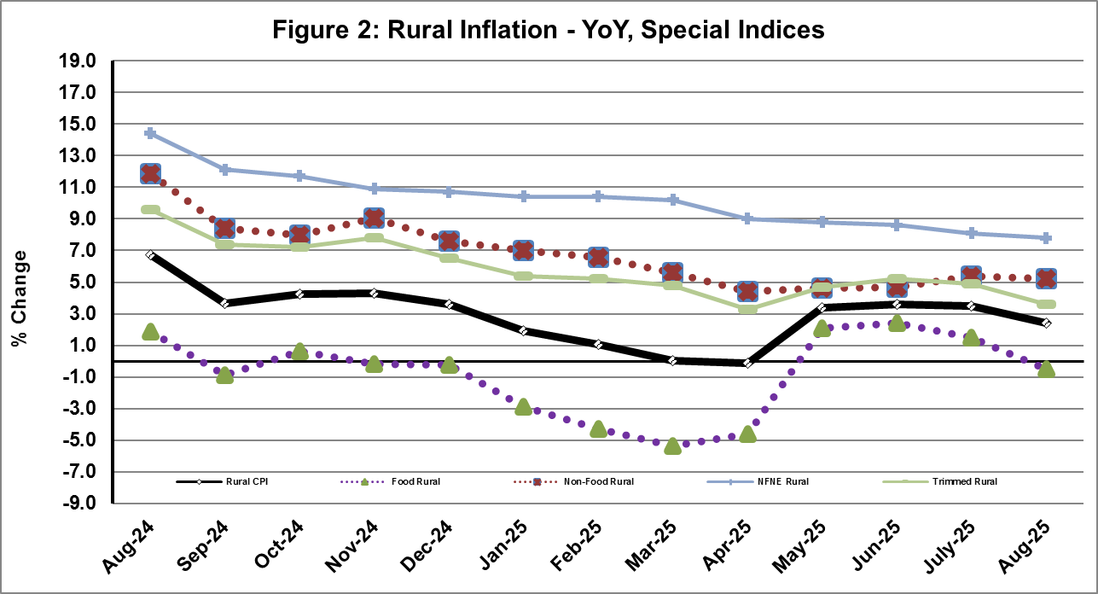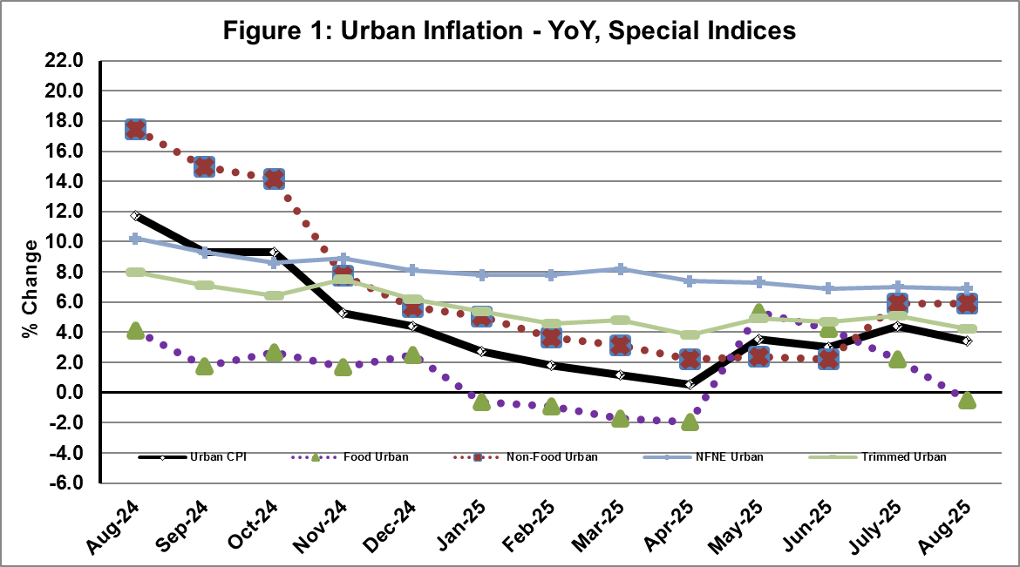

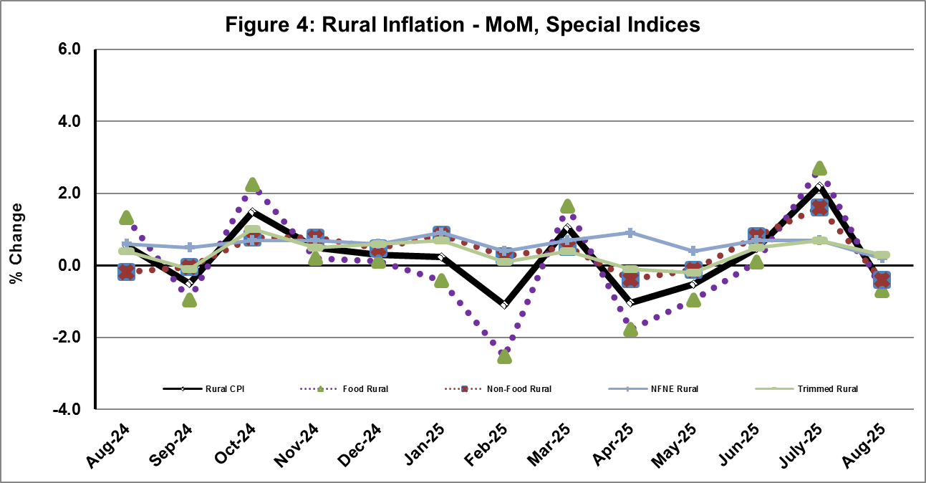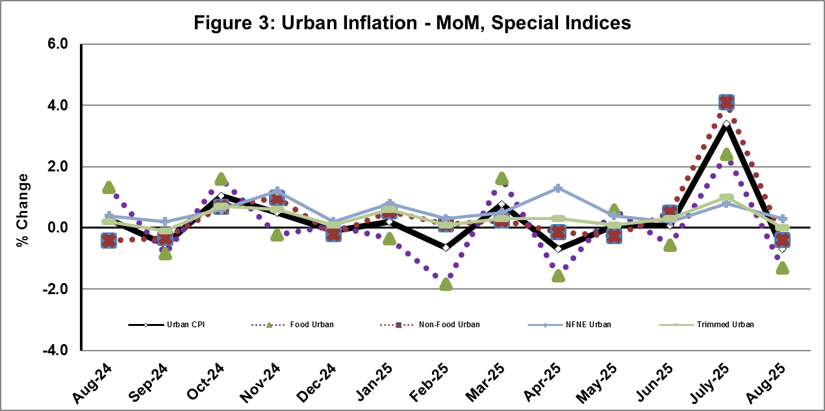

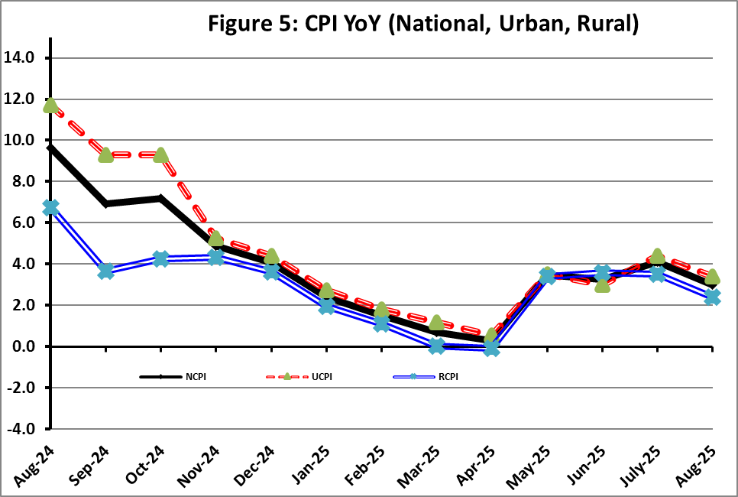

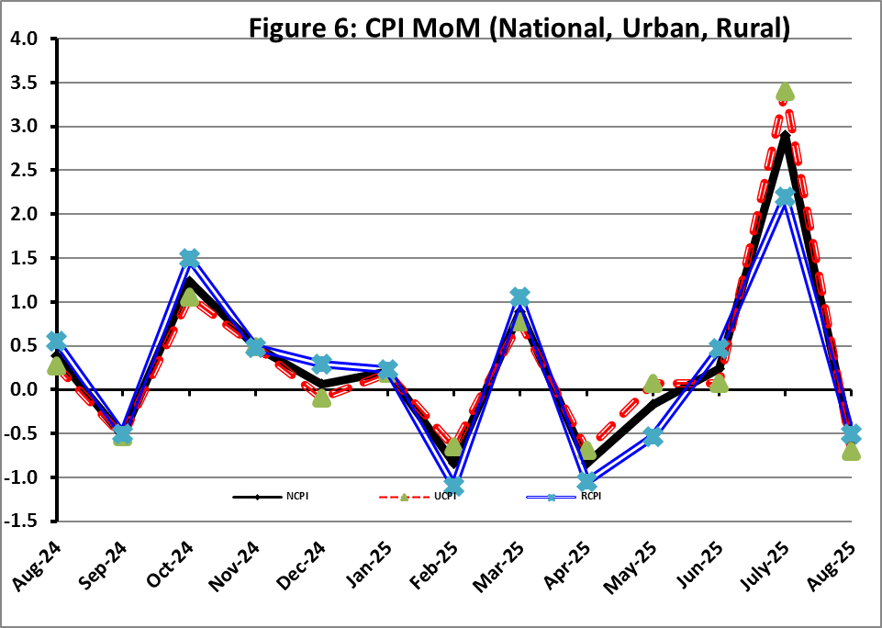

**I. National Consumer Price Index (N-CPI)**

The **National Consumer Price Index** for **August 2025** is decreased by **0.65%** over **July 2025** and increased by **2.99%** over corresponding month of the last year i.e. **August 2024**.

|  |  |  |  |  |  |  |  |  |  |
| --- | --- | --- | --- | --- | --- | --- | --- | --- | --- |
| Table 1: Consumer Price Index (National) by Group of Commodities and Services (Base 2015-16) | | | | | | | | | |
| No | Group | Group  Weight  (%) | Indices | | | % Change  Aug 2025  Over | | Impact  (In % points)  Aug 2025 Over | |
| Aug 25 | July 25 | Aug 24 | July 25 | Aug 24 | July 25 | Aug 24 |
| General | 100.00 | **270.18** | **271.94** | **262.32** | **-0.65** | **2.99** | **-0.65** | **2.99** |
| 1. | Food & Non-alcoholic Bev. | 34.58 | 275.70 | 279.15 | 280.72 | -1.23 | -1.79 | -0.44 | -0.66 |
|  | *Non-perishable Food Items* | 29.60 | 281.20 | 279.60 | 275.81 | 0.57 | 1.95 | 0.17 | 0.61 |
| *Perishable Food Items* | 4.99 | 243.08 | 276.46 | 309.89 | -12.07 | -21.56 | -0.61 | -1.27 |
| 2. | Alcoholic Bev. & Tobacco | 1.02 | 397.79 | 397.44 | 384.09 | 0.09 | 3.57 | 0.00 | 0.05 |
| 3. | Clothing & Footwear | 8.60 | 264.70 | 264.17 | 244.84 | 0.20 | 8.11 | 0.02 | 0.65 |
| 4. | Housing, Water, Electricity, Gas & Fuels | 23.63 | 245.49 | 248.87 | 236.93 | -1.36 | 3.61 | -0.29 | 0.77 |
| 5. | Furnishing & Household Equipment Maintenance | 4.10 | 279.69 | 278.73 | 270.22 | 0.34 | 3.50 | 0.01 | 0.15 |
| 6. | Health | 2.79 | 277.20 | 275.24 | 250.63 | 0.71 | 10.60 | 0.02 | 0.28 |
| 7. | Transport | 5.91 | 317.93 | 321.04 | 310.22 | -0.97 | 2.49 | -0.07 | 0.17 |
| 8. | Communication | 2.21 | 135.31 | 135.26 | 134.67 | 0.04 | 0.47 | 0.00 | 0.01 |
| 9. | Recreation & Culture | 1.59 | 267.34 | 266.49 | 273.53 | 0.32 | -2.27 | 0.00 | -0.04 |
| 10. | Education | 3.79 | 222.97 | 220.15 | 200.98 | 1.28 | 10.94 | 0.04 | 0.32 |
| 11. | Restaurants & Hotels | 6.92 | 290.50 | 289.95 | 271.11 | 0.19 | 7.15 | 0.01 | 0.51 |
| 12. | Miscellaneous | 4.87 | 333.52 | 331.35 | 291.56 | 0.66 | 14.39 | 0.04 | 0.78 |

II. Urban Consumer Price Index (UCPI)

The Urban Consumer Price Index for **August 2025** is decreased by **0.73%** over **July 2025** and increased by **3.38%** over corresponding month of the last year i.e. **August 2024**.

|  |  |  |  |  |  |  |  |  |  |
| --- | --- | --- | --- | --- | --- | --- | --- | --- | --- |
| Table 2: Consumer Price Index (Urban) by Group of Commodities and Services (Base 2015-16) | | | | | | | | | |
| No | Group | Group  Weight  (%) | Indices | | | % Change  Aug 2025  Over | | Impact  (In % points)  Aug 2025 Over | |
| Aug 25 | July 25 | Aug 24 | July 25 | Aug 24 | July 25 | Aug 24 |
|  | General | 100.00 | **268.06** | **270.04** | **259.30** | **-0.73** | **3.38** | **-0.73** | **3.38** |
| 1. | Food & Non-alcoholic Bev. | 30.42 | 274.75 | 279.27 | 280.27 | -1.62 | -1.97 | -0.51 | -0.65 |
|  | *Non-perishable Food Items* | 25.97 | 280.77 | 279.90 | 275.13 | 0.31 | 2.05 | 0.08 | 0.56 |
|  | *Perishable Food Items* | 4.46 | 239.65 | 275.57 | 310.24 | -13.03 | -22.75 | -0.59 | -1.21 |
| 2. | Alcoholic Bev. & Tobacco | 0.85 | 420.23 | 419.92 | 407.24 | 0.07 | 3.19 | 0.00 | 0.04 |
| 3. | Clothing & Footwear | 8.01 | 255.32 | 254.87 | 236.21 | 0.18 | 8.09 | 0.01 | 0.59 |
| 4. | Housing, Water, Electricity, Gas & Fuels | 27.03 | 255.60 | 258.93 | 243.39 | -1.29 | 5.02 | -0.33 | 1.27 |
| 5. | Furnishing & Household Equip. & Maintenance | 4.09 | 269.71 | 268.22 | 259.86 | 0.56 | 3.79 | 0.02 | 0.16 |
| 6. | Health | 2.31 | 278.71 | 276.72 | 253.98 | 0.72 | 9.74 | 0.02 | 0.22 |
| 7. | Transport | 6.14 | 312.80 | 315.95 | 305.69 | -1.00 | 2.33 | -0.07 | 0.17 |
| 8. | Communication | 2.35 | 138.68 | 138.62 | 138.30 | 0.04 | 0.27 | 0.00 | 0.00 |
| 9. | Recreation & Culture | 1.73 | 251.61 | 250.53 | 259.63 | 0.43 | -3.09 | 0.01 | -0.05 |
| 10. | Education | 4.88 | 216.13 | 212.70 | 195.37 | 1.61 | 10.63 | 0.06 | 0.39 |
| 11. | Restaurants & Hotels | 7.41 | 284.54 | 283.97 | 266.75 | 0.20 | 6.67 | 0.02 | 0.51 |
| 12. | Miscellaneous | 4.77 | 323.39 | 321.00 | 283.85 | 0.74 | 13.93 | 0.04 | 0.73 |

Main contributors to month-on-month and year-on-year percentage changes are given below and detail is given in **Annexure-A**.

1. **MONTH-ON-MONTH Top few commodities which varied from previous month i.e. July, 2025 are given below:**

**FOOD**

***Increased*:** Tomatoes (19.63%), Onions (14.38%), Eggs (12.84%), Chicken (4.16%), Butter (3.21%), Fish (1.46%), Gur (0.79%), Rice (0.73%), Condiments and Spices (0.64%), Meat (0.41%), Milk Powder (0.34%) and Readymade Food (0.26%).

***Decreased***: Fresh Fruits (21.16%), Fresh Vegetables (18.48%), Potatoes (8.77%), Sugar (5.49%), Pulse Moong (2.81%), Gram Whole (2.16%), Pulse Gram (2.09%), Pulse Mash (1.40%), Wheat Products (1.31%), Wheat Flour (1.24%), Pulse Masoor (0.82%) and Besan (0.49%).

**NON-FOOD:**

***Increased*:** Newspapers (11.93%), Hospitals Services (1.71%), Education (1.61%), Cleaning & Laundring (1.41%) and Doctor (MBBS) Clinic Fee (1.21%).

***Decreased:*** Liquified Hydrocarbons (7.30%), Electricity Charges (6.87%), Motor Fuel (1.51%) and Transport Services (0.71%).

**YEAR-ON-YEAR: Top few commodities, which varied from corresponding month of previous year i.e. August 2024, are given below:**

**FOOD**

***Increased*:** Sugar (22.30%), Honey (17.90%), Condiments and Spices (14.85%), Gur (13.83%), Pulse Moong (12.94%), Vegetable Ghee (10.93%), Meat (10.50%), Mustard Oil (8.10%), Fish (8.08%), Readymade Food (7.30%) and Cooking Oil (6.56%).

***Decreased***: Onions (50.98%), Tomatoes (31.82%), Fresh Vegetables (26.08%), Pulse Mash (24.92%), Wheat Flour (19.37%), Wheat (18.39%), Potatoes (18.23%), Tea (17.75%), Pulse Gram (12.47%), Wheat Products (10.82%), Gram Whole (10.29%), Pulse Masoor (9.45%), Besan (7.94%), Beans (2.41%) and Chicken (1.26%).

**NON-FOOD:**

***Increased:*** Gas Charges (22.91%), Electrical Appliances (17.57%), Newspapers (14.61%), Water Supply (14.29%), Household Textiles (13.18%), Footware (12.70%), Dental Services (11.39%), Woollen Readymade Garments (11.28%) and Drugs & Medicines (10.98%).

***Decreased***: Electricity Charges (17.22%), Liquified Hydrocarbons (8.00%), Text Books (7.75%), Washing Soap/Detergents/Match Box (0.98%) and Stationery (0.08%).**III. Rural Consumer Price Index (RCPI)**

The **Rural Consumer Price Index** for **August 2025** is decreased by **0.52%** over **July 2025** and increased by **2.43%** over corresponding month of the last year i.e. **August 2024**.

|  |  |  |  |  |  |  |  |  |  |
| --- | --- | --- | --- | --- | --- | --- | --- | --- | --- |
| Table 3: Consumer Price Index (Rural) by Group of Commodities and Services (Base 2015-16) | | | | | | | | | |
| No | Group | Group  Weight  (%) | Indices | | | % Change  Aug 2025  Over | | Impact  (In % points)  Aug 2025 Over | |
| Aug 25 | July 25 | Aug 24 | July 25 | Aug 24 | July 25 | Aug 24 |
|  | General | 100.00 | **273.37** | **274.81** | **266.89** | **-0.52** | **2.43** | **-0.52** | **2.43** |
| 1. | Food & Non-alcoholic Bev. | 40.87 | 276.77 | 279.01 | 281.23 | -0.80 | -1.59 | -0.33 | -0.68 |
|  | *Non-perishable Food Items* | *35.08* | 281.68 | 279.26 | 276.57 | 0.87 | 1.85 | 0.31 | 0.67 |
|  | *Perishable Food Items* | *5.79* | 247.06 | 277.49 | 309.48 | -10.97 | -20.17 | -0.64 | -1.35 |
| 2. | Alcoholic Bev. & Tobacco | 1.28 | 375.17 | 374.78 | 360.75 | 0.10 | 4.00 | 0.00 | 0.07 |
| 3. | Clothing & Footwear | 9.48 | 276.67 | 276.03 | 255.85 | 0.23 | 8.14 | 0.02 | 0.74 |
| 4. | Housing, Water, Electricity, Gas & Fuels | 18.49 | 223.19 | 226.67 | 222.68 | -1.54 | 0.23 | -0.23 | 0.03 |
| 5. | Furnishing & Household Equip. & Maintenance | 4.10 | 294.70 | 294.55 | 285.81 | 0.05 | 3.11 | 0.00 | 0.14 |
| 6. | Health | 3.51 | 275.70 | 273.77 | 247.30 | 0.70 | 11.48 | 0.02 | 0.37 |
| 7. | Transport | 5.56 | 326.48 | 329.51 | 317.76 | -0.92 | 2.74 | -0.06 | 0.18 |
| 8. | Communication | 1.99 | 129.31 | 129.28 | 128.21 | 0.02 | 0.86 | 0.00 | 0.01 |
| 9. | Recreation & Culture | 1.38 | 297.17 | 296.78 | 299.91 | 0.13 | -0.91 | 0.00 | -0.01 |
| 10. | Education | 2.13 | 246.57 | 245.87 | 220.36 | 0.28 | 11.89 | 0.01 | 0.21 |
| 11. | Restaurants & Hotels | 6.19 | 301.25 | 300.75 | 278.98 | 0.17 | 7.98 | 0.01 | 0.52 |
| 12. | Miscellaneous | 5.02 | 348.07 | 346.21 | 302.62 | 0.54 | 15.02 | 0.03 | 0.85 |

Main contributors to Month-on-Month and Year-on-Year percentage changes are given below and detail is given in **Annexure-B**.

1. **MONTH-ON-MONTH Top few commodities which varied from previous month i.e.July, 2025 are given below:**

**FOOD**

***Increased:*** Onions (27.16%), Tomatoes (19.49%), Eggs (10.28%), Chicken (4.12%), Wheat Flour (2.54%), Wheat (1.81%), Bakery And Confectionary (1.46%), Milk Powder (1.23%), Milk Fresh (1.21%) and Meat (1.16%).

***Decreased:*** Fresh Ruits (22.50%), Fresh Vegetables (18.71%), Pulse Moong (6.02%), Sugar (3.12%), Pulse Mash (1.74%), Besan (1.45%), Gram Whole (1.40%), Pulse Gram (1.27%), Wheat Products (1.15%), Beans (1.04%), Fish (0.92%), Potatoes (0.59%) and Tea (0.33%).

**NON-FOOD**

***Increased:*** Dental Services (4.38%), Newspapers (3.23%), Medical Tests (1.31%), Drugs and Medicines (0.92%), Hosiry (0.71%), Construction Input Items (0.63%), Construction Wage Rates (0.48%), Doctor Clinic Fee (0.43%), Solid Fuel (0.36%).

***Decreased:*** Electricity Charges (6.87%), Liquified Hydrocarbons (3.67%), Motor Fuels (1.62%), Transport Services (0.32%).

**YEAR-ON-YEAR: Top few commodities which varied from corresponding month of previous year i.e. August, 2024 are given below:**

**FOOD**

***Increased:*** Sugar (26.14%), Honey (19.63%), Meat (15.51%), Dry Fruits (13.09%), Vegetable Ghee (12.04%), Cooking Oil (10.40%), Pulse Moong (9.06%), Readymade Food (8.90%), Mustard Oil (7.19%), Milk Fresh (6.03%), Eggs (5.84%), Milk Powder (5.72%).

***Decreased:*** Onions (50.24%), Tomatoes (25.02%), Pulse Mash (21.28%), Fresh Vegetables (19.74%), Potatoes (19.03%), Tea (18.22%), Wheat (17.29%), Wheat Flour (16.49%), Wheat Products (11.82%), Pulse Gram (9.38%), Pulse Masoor (6.31%), Gram Whole (1.99%), Chicken (1.65%), Beans (1.22%) and Besan (0.57%).

**NON-FOOD**

***Increased:*** Dental Services (28.06%), Doctor Clinic Fee (13.91%) and Drugs & Medicines (13.25%).

***Decreased:*** Electricity Charges (17.22%), Text Books (10.98%) and Liquified Hydrocarbons (5.42%).

**IV.** **Sensitive Price Indicator**

Quintile-wise percentage changes YoY and MoM are given below in Table 4. The series from

August 2024 to August 2025 is also graphed below in Figure 7.

|  |  |  |  |  |  |
| --- | --- | --- | --- | --- | --- |
| Table 4: Sensitive Price Indicator (Base 2015-16) | | | | | |
| Quintiles | Indices | | | % Change Aug 2025  Over | |
| Aug 25 | July 25 | Aug 24 | July 25 | Aug 24 |
| 1 | 318.57 | 308.58 | 310.40 | 3.24 | 2.63 |
| 2 | 318.16 | 305.99 | 308.22 | 3.98 | 3.22 |
| 3 | 341.34 | 330.09 | 331.78 | 3.41 | 2.88 |
| 4 | 329.26 | 319.71 | 320.90 | 2.99 | 2.61 |
| 5 | 328.73 | 321.55 | 323.58 | 2.23 | 1.59 |
| Combined | 329.29 | 319.73 | 321.44 | 2.99 | 2.44 |

|  |  |  |  |  |
| --- | --- | --- | --- | --- |
| **Table 4.1: Weekly Percentage Change of SPI During August 2025** | | | | |
| **Quintiles** | **% Change over Previous week** | | | |
| **07-08-2025** | **13-08-2025** | **21-08-2025** | **28-08-2025** |
| Quintile 1 | 0.30 | 0.31 | 0.20 | 0.84 |
| Combined | 0.05 | 0.31 | -0.01 | 0.62 |

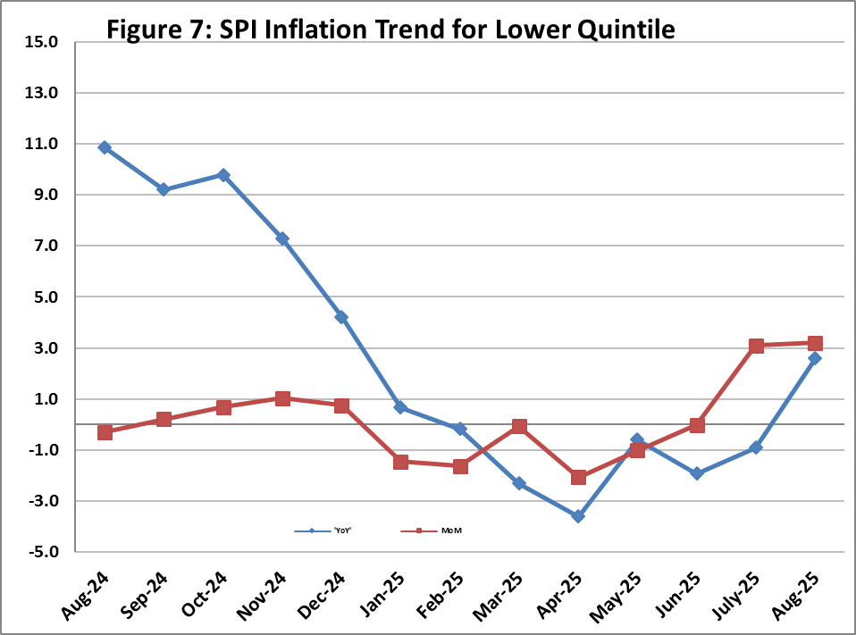

**V. Wholesale Price Index**

The Wholesale Price Index for **August 2025** decreased by **0.21%** over **July 2025** and decreased by **1.00%** over the corresponding month of the last year i.e. **August, 2024**. YoY and MoM movements from August, 2024 to August, 2025 are also graphed below in Figure 8.

|  |  |  |  |  |  |  |  |  |  |  |
| --- | --- | --- | --- | --- | --- | --- | --- | --- | --- | --- |
| Table 5: Wholesale Price Index by Group of Commodities (Base 2015-16) | | | | | | | | | | |
| No | Group | Group  Weight  (%) | Indices | | | % Change  Aug 2025  Over | | Impact  (In % points)  Aug 2025 Over | |
| Aug 25 | July 25 | Aug 24 | July 25 | Aug 24 | July 25 | Aug 24 |
|  | General | 100.00 | **313.68** | **314.33** | **316.84** | **-0.21** | **-1.00** | **-0.21** | **-1.00** |
| 1 | Agriculture Forestry & Fishery | 25.77 | 278.18 | 280.73 | 289.40 | -0.91 | -3.88 | -0.21 | -0.91 |
| 2 | Ores/Minerals, Elec., Gas & Water | 12.01 | 352.31 | 359.18 | 375.03 | -1.91 | -6.06 | -0.26 | -0.86 |
| 3 | Food, Beverages, Tobacco, Textiles & Leather Products | 31.11 | 284.96 | 283.50 | 271.54 | 0.51 | 4.94 | 0.14 | 1.32 |
|  | i. Food Products, Beverages & Tobacco | 20.07 | 301.25 | 300.40 | 285.48 | 0.28 | 5.52 | 0.05 | 1.00 |
|  | ii. Textiles & Apparels | 10.33 | 260.63 | 257.88 | 250.12 | 1.07 | 4.20 | 0.09 | 0.34 |
|  | iii. Leather Products | 0.71 | 178.56 | 178.56 | 188.92 | 0.00 | -5.48 | 0.00 | -0.02 |
| 4 | Other Transportable Goods | 22.40 | 342.32 | 342.33 | 351.85 | 0.00 | -2.71 | 0.00 | -0.67 |
| 5 | Metal Product, Machinery & Equipment | 8.72 | 394.27 | 389.98 | 389.55 | 1.10 | 1.21 | 0.12 | 0.13 |

Main contributors to month-on-month and year-on-year percentage changes are given below and detail is given in **Annexure-C**.

1. **MONTH-ON-MONTH:** **Top few commodities which varied from previous month are given below:**

**Increased:** Eggs (13.73%), Insecticides (13.45%), Cotton Fabrics (8.14%), Other Glass Articles (5.21%), Synthetic Carpets (4.27%), Other Food Products (3.77%), Bicycles (3.61%), Salt & Pure Sodium Chloride (3.53%), Dry Fruits (3.42%), Other Fabrics (3.19%), Poultry (3.16%).

**Decreased:** Vegetables (11.39%), Fresh Fruits (10.04%), Millet / Bajra (4.81%), Electrical Energy (4.59%), Sugar Refined (3.15%), Pulses (2.82%), Edible Roots / Potatoes (2.63%), Oil Cakes (1.98%), Motor Spirit (1.85%), Diesel Oil (0.64%), Kerosene Oil (0.55%).

**YEAR-ON-YEAR: Top few commodities which varied from previous year are given below:**

**Increased:** Other Food Products (51.57%), Sugar Confectionary (33.18%), Sugar Refined (24.57%), Dyeing Material (22.99%), Sorghum / Jowar (20.20%), Millet / Bajra (18.28%), Electric Wires (18.04%) and Sugar Crops (17.93%).

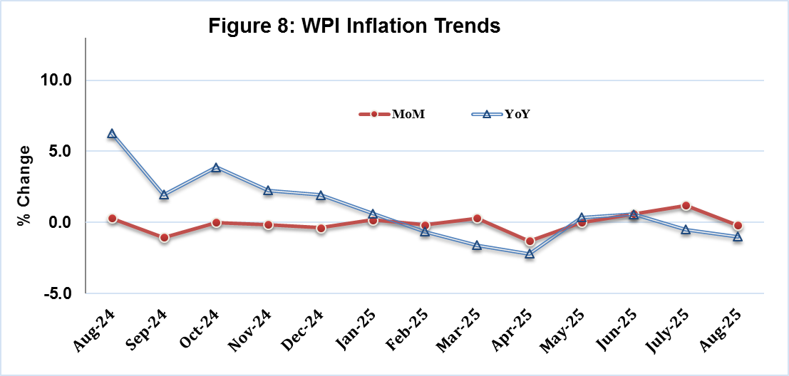**Decreased:** Vegetables (36.34%), Electrical Energy (21.35%), Edible Roots / Potatoes (19.09%), Furnace Oil (18.92%), Wheat (17.37%), Wheat Flour (17.3%), Stimulant & Spice Crops (14.28%), Pulses (11.15%) and Steel Bar & Sheets (9.68%).

| **Annexure A: CPI (Urban) Index Numbers by Commodity Groups & Commodities (2015-16=100)** | | | | | | | | | | | |
| --- | --- | --- | --- | --- | --- | --- | --- | --- | --- | --- | --- |
| Item and Specification | | Weight | Index Numbers  Aug 25 Jul 25 Aug 24 | | | % Change in Aug 2025 over  Jul 2025 Aug 2024 | | | | | | |
|  | ***General*** | ***100.0000*** | ***268.06*** | ***270.04*** | ***259.30*** |  | ***-*** | ***0.73*** |  | ***+*** | ***3.38*** | |
|  | ***Food and non-alcoholic Beverage*** | ***30.4215*** | ***274.75*** | ***279.27*** | ***280.27*** |  | ***-*** | ***1.62*** |  | ***-*** | ***1.97*** | |
| 01 | Wheat | 0.6120 | 189.35 | 189.03 | 232.01 |  | + | 0.17 |  | - | 18.39 | |
| 02 | Wheat flour | 3.0075 | 193.92 | 196.36 | 240.52 |  | - | 1.24 |  | - | 19.37 | |
| 03 | Wheat products | 0.0936 | 262.39 | 265.88 | 294.24 |  | - | 1.31 |  | - | 10.82 | |
| 04 | Besan | 0.0830 | 251.59 | 252.84 | 273.29 |  | - | 0.49 |  | - | 7.94 | |
| 05 | Rice | 1.1804 | 321.76 | 319.42 | 313.42 |  | + | 0.73 |  | + | 2.66 | |
| 06 | Bakery and confectionary | 0.4770 | 269.45 | 269.17 | 260.50 |  | + | 0.10 |  | + | 3.44 | |
| 07 | Nimco | 0.1224 | 300.77 | 300.45 | 288.04 |  | + | 0.11 |  | + | 4.42 | |
| 08 | Meat | 2.0411 | 345.89 | 344.49 | 313.03 |  | + | 0.41 |  | + | 10.50 | |
| 09 | Chicken | 1.3631 | 309.48 | 297.11 | 313.44 |  | + | 4.16 |  | - | 1.26 | |
| 10 | Fish | 0.3855 | 210.99 | 207.96 | 195.22 |  | + | 1.46 |  | + | 8.08 | |
| 11 | Milk fresh | 7.1070 | 265.95 | 265.43 | 258.57 |  | + | 0.20 |  | + | 2.85 | |
| 12 | Milk products | 0.6407 | 268.22 | 267.79 | 262.96 |  | + | 0.16 |  | + | 2.00 | |
| 13 | Milk powder | 0.3106 | 317.07 | 316.00 | 301.95 |  | + | 0.34 |  | + | 5.01 | |
| 14 | Eggs | 0.5083 | 345.94 | 306.58 | 328.38 |  | + | 12.84 |  | + | 5.35 | |
| 15 | Butter | 0.0932 | 460.89 | 446.57 | 375.71 |  | + | 3.21 |  | + | 22.67 | |
| 16 | Mustard oil | 0.0120 | 308.24 | 308.67 | 285.15 |  | - | 0.14 |  | + | 8.10 | |
| 17 | Cooking oil | 1.1016 | 324.73 | 325.00 | 304.74 |  | - | 0.08 |  | + | 6.56 | |
| 18 | Vegetable ghee | 1.0324 | 343.22 | 343.62 | 309.40 |  | - | 0.12 |  | + | 10.93 | |
| 19 | Dry fruits | 0.3299 | 298.48 | 298.42 | 282.43 |  | + | 0.02 |  | + | 5.68 | |
| 20 | Fresh fruits | 1.4363 | 218.50 | 277.14 | 215.89 |  | - | 21.16 |  | + | 1.21 | |
| 21 | Pulse masoor | 0.1624 | 200.28 | 201.94 | 221.18 |  | - | 0.82 |  | - | 9.45 | |
| 22 | Pulse moong | 0.1697 | 238.41 | 245.30 | 211.09 |  | - | 2.81 |  | + | 12.94 | |
| 23 | Pulse mash | 0.1152 | 187.97 | 190.63 | 250.35 |  | - | 1.40 |  | - | 24.92 | |
| 24 | Pulse gram | 0.1660 | 248.07 | 253.37 | 283.41 |  | - | 2.09 |  | - | 12.47 | |
| 25 | Gram whole | 0.0912 | 270.77 | 276.74 | 301.84 |  | - | 2.16 |  | - | 10.29 | |
| 26 | Beans | 0.0408 | 366.50 | 367.90 | 375.57 |  | - | 0.38 |  | - | 2.41 | |
| 27 | Potatoes | 0.4496 | 324.13 | 355.30 | 396.38 |  | - | 8.77 |  | - | 18.23 | |
| 28 | Onions | 0.5928 | 160.74 | 140.53 | 327.94 |  | + | 14.38 |  | - | 50.98 | |
| 29 | Tomatoes | 0.3459 | 245.86 | 205.52 | 360.58 |  | + | 19.63 |  | - | 31.82 | |
| 30 | Fresh vegetables | 1.5306 | 254.16 | 311.77 | 343.82 |  | - | 18.48 |  | - | 26.08 | |
| 31 | Sugar | 1.1130 | 286.12 | 302.74 | 233.94 |  | - | 5.49 |  | + | 22.30 | |
| 32 | Gur | 0.0379 | 273.43 | 271.28 | 240.21 |  | + | 0.79 |  | + | 13.83 | |
| 33 | Honey | 0.1017 | 222.69 | 222.58 | 188.88 |  | + | 0.05 |  | + | 17.90 | |
| 34 | Sweetmeat | 0.3535 | 331.14 | 329.58 | 299.43 |  | + | 0.47 |  | + | 10.59 | |
| 35 | Ice cream | 0.1044 | 199.68 | 199.68 | 199.33 |  | + | 0.00 |  | + | 0.18 | |
| 36 | Condiments and Spices | 1.3340 | 372.15 | 369.77 | 324.02 |  | + | 0.64 |  | + | 14.85 | |
| 37 | Dessert preparation | 0.0419 | 297.85 | 297.12 | 262.83 |  | + | 0.25 |  | + | 13.32 | |
| 38 | Tea | 0.8427 | 273.67 | 273.67 | 332.73 |  | + | 0.00 |  | - | 17.75 | |
| 39 | Beverages | 0.8906 | 261.06 | 261.58 | 250.41 |  | - | 0.20 |  | + | 4.25 | |
|  | ***Alcoholic Beverages, Tobacco*** | ***0.8540*** | ***420.23*** | ***419.92*** | ***407.24*** |  | ***+*** | ***0.07*** |  | ***+*** | ***3.19*** | |
| 40 | Cigarettes | 0.7167 | 411.55 | 411.55 | 405.76 |  | + | 0.00 |  | + | 1.43 | |
| 41 | Pan prepared | 0.1373 | 465.58 | 463.64 | 414.94 |  | + | 0.42 |  | + | 12.20 | |
|  | ***Clothing and footwear*** | ***8.0096*** | ***255.32*** | ***254.87*** | ***236.21*** |  | ***+*** | ***0.18*** |  | ***+*** | ***8.09*** | |
| 42 | Cotton cloth | 2.2227 | 298.53 | 298.32 | 279.69 |  | + | 0.07 |  | + | 6.74 | |
| 43 | Woollen cloth | 0.8361 | 243.55 | 243.09 | 225.56 |  | + | 0.19 |  | + | 7.98 | |
| 44 | Readymade garments | 1.3196 | 222.92 | 221.16 | 205.00 |  | + | 0.80 |  | + | 8.74 | |
| 45 | Woollen readymade garments | 0.4307 | 256.71 | 256.71 | 230.68 |  | + | 0.00 |  | + | 11.28 | |
| 46 | Tailoring | 1.0741 | 237.76 | 237.68 | 227.53 |  | + | 0.03 |  | + | 4.50 | |
| 47 | Hosiery | 0.4070 | 239.41 | 239.30 | 226.45 |  | + | 0.05 |  | + | 5.72 | |
| 48 | Dopatta | 0.1713 | 205.28 | 205.16 | 191.92 |  | + | 0.06 |  | + | 6.96 | |
| 49 | Cleaning and laundering | 0.0665 | 276.51 | 272.66 | 255.72 |  | + | 1.41 |  | + | 8.13 | |
| 50 | Footwear | 1.4816 | 247.53 | 247.53 | 219.63 |  | + | 0.00 |  | + | 12.70 | |
|  | ***Housing, water, Elec., Gas and other Fuels*** | ***27.0332*** | ***255.60*** | ***258.93*** | ***243.39*** |  | ***-*** | ***1.29*** |  | ***+*** | ***5.02*** | |
| 51 | House rent | 19.2558 | 172.97 | 172.97 | 164.08 |  | + | 0.00 |  | + | 5.42 | |
| 52 | Construction input items | 0.3765 | 268.48 | 268.15 | 266.39 |  | + | 0.12 |  | + | 0.78 | |
| 53 | Construction wage rates | 0.2025 | 227.64 | 227.57 | 215.95 |  | + | 0.03 |  | + | 5.41 | |
| 54 | Water supply | 0.5269 | 230.44 | 228.99 | 201.62 |  | + | 0.63 |  | + | 14.29 | |
| 55 | Garbage collection | 0.1064 | 265.81 | 265.81 | 250.31 |  | + | 0.00 |  | + | 6.19 | |
| 56 | Electricity charges | 4.5562 | 235.48 | 252.84 | 284.46 |  | - | 6.87 |  | - | 17.22 | |
| 57 | Gas charges | 1.0807 | 1817.96 | 1817.96 | 1479.08 |  | + | 0.00 |  | + | 22.91 | |
| 58 | Liquefied Hydrocarbons | 0.5064 | 295.37 | 318.63 | 321.05 |  | - | 7.30 |  | - | 8.00 | |
| 59 | Solid Fuel | 0.4218 | 225.46 | 224.94 | 204.49 |  | + | 0.23 |  | + | 10.25 | |
|  | ***Furnishing and household equipments*** | ***4.0937*** | ***269.71*** | ***268.22*** | ***259.86*** |  | ***+*** | ***0.56*** |  | ***+*** | ***3.79*** | |
| 60 | Furniture and furnishing | 0.4750 | 262.63 | 261.25 | 247.94 |  | + | 0.53 |  | + | 5.92 | |
| 61 | Carpets | 0.0308 | 154.14 | 154.07 | 149.43 |  | + | 0.05 |  | + | 3.15 | |
| 62 | Household textiles | 0.3420 | 210.31 | 210.16 | 185.82 |  | + | 0.07 |  | + | 13.18 | |
| 63 | Household equipments | 1.0032 | 273.66 | 273.09 | 256.45 |  | + | 0.21 |  | + | 6.71 | |
| 64 | Plastic products | 0.0536 | 233.56 | 233.54 | 212.01 |  | + | 0.01 |  | + | 10.16 | |
| 65 | Major tools & equipments | 0.0084 | 251.27 | 250.42 | 232.35 |  | + | 0.34 |  | + | 8.14 | |
| 66 | Washing soap/detergents/match | 1.4112 | 322.82 | 319.51 | 326.03 |  | + | 1.04 |  | - | 0.98 | |
| 67 | Household servant | 0.7695 | 205.26 | 205.08 | 191.26 |  | + | 0.09 |  | + | 7.32 | |
|  | ***Health*** | ***2.3098*** | ***278.71*** | ***276.72*** | ***253.98*** |  | ***+*** | ***0.72*** |  | ***+*** | ***9.74*** | |
| 68 | Drugs and medicines | 1.0735 | 298.59 | 298.04 | 269.05 |  | + | 0.18 |  | + | 10.98 | |
| 69 | Therapeutic Appliances and Equipments | 0.0054 | 155.67 | 155.64 | 150.70 |  | + | 0.02 |  | + | 3.30 | |
| 70 | Doctor (MBBS) clinic fee | 0.4044 | 351.91 | 347.69 | 319.39 |  | + | 1.21 |  | + | 10.18 | |
| 71 | Dental services | 0.0156 | 230.24 | 229.35 | 206.69 |  | + | 0.39 |  | + | 11.39 | |
| 72 | Medical tests | 0.2367 | 215.91 | 215.14 | 195.40 |  | + | 0.36 |  | + | 10.50 | |
| 73 | Hospitals services | 0.5742 | 218.35 | 214.68 | 206.15 |  | + | 1.71 |  | + | 5.92 | |
|  | ***Transport*** | ***6.1368*** | ***312.80*** | ***315.95*** | ***305.69*** |  | ***-*** | ***1.00*** |  | ***+*** | ***2.33*** | |
| 74 | Motor vehicles | 0.8097 | 267.19 | 267.39 | 259.33 |  | - | 0.07 |  | + | 3.03 | |
| 75 | Motor vehicle accessories | 0.1941 | 265.92 | 265.36 | 259.13 |  | + | 0.21 |  | + | 2.62 | |
| 76 | Motor fuel | 2.9088 | 360.20 | 365.73 | 359.75 |  | - | 1.51 |  | + | 0.13 | |
| 77 | Mechanical services | 0.4290 | 238.72 | 238.01 | 224.23 |  | + | 0.30 |  | + | 6.46 | |
| 78 | Motor vehicle tax | 0.0482 | 399.23 | 399.23 | 399.23 |  | + | 0.00 |  | + | 0.00 | |
| 79 | Transport services | 1.7470 | 276.04 | 278.02 | 259.76 |  | - | 0.71 |  | + | 6.27 | |
|  | ***Communication*** | ***2.3536*** | ***138.68*** | ***138.62*** | ***138.30*** |  | ***+*** | ***0.04*** |  | ***+*** | ***0.27*** | |
| 80 | Postal services | 0.0190 | 221.59 | 221.59 | 209.23 |  | + | 0.00 |  | + | 5.91 | |
| 81 | Communication apparatus | 0.4524 | 189.85 | 189.52 | 188.35 |  | + | 0.17 |  | + | 0.80 | |
| 82 | Communication Services | 1.8822 | 125.55 | 125.55 | 125.55 |  | + | 0.00 |  | + | 0.00 | |
|  | ***Recreation and culture*** | ***1.7301*** | ***251.61*** | ***250.53*** | ***259.63*** |  | ***+*** | ***0.43*** |  | ***-*** | ***3.09*** | |
| 83 | Recreation and culture | 0.6478 | 155.07 | 155.07 | 153.29 |  | + | 0.00 |  | + | 1.16 | |
| 84 | Text books | 0.6655 | 306.66 | 306.66 | 332.44 |  | + | 0.00 |  | - | 7.75 | |
| 85 | Newspapers | 0.0716 | 242.82 | 216.94 | 211.87 |  | + | 11.93 |  | + | 14.61 | |
| 86 | stationery | 0.3452 | 328.45 | 328.43 | 328.70 |  | + | 0.01 |  | - | 0.08 | |
|  | ***Education*** | ***4.8807*** | ***216.13*** | ***212.70*** | ***195.37*** |  | ***+*** | ***1.61*** |  | ***+*** | ***10.63*** | |
| 87 | Education | 4.8807 | 216.13 | 212.70 | 195.37 |  | + | 1.61 |  | + | 10.63 | |
|  | ***Restaurants and hotels*** | ***7.4050*** | ***284.54*** | ***283.97*** | ***266.75*** |  | ***+*** | ***0.20*** |  | ***+*** | ***6.67*** | |
| 88 | Readymade food | 5.5235 | 291.51 | 290.75 | 271.68 |  | + | 0.26 |  | + | 7.30 | |
| 89 | Marriage Hall Charges | 1.7514 | 270.21 | 270.21 | 258.50 |  | + | 0.00 |  | + | 4.53 | |
| 90 | Accommodation Services | 0.1301 | 181.32 | 181.32 | 168.39 |  | + | 0.00 |  | + | 7.68 | |
|  | ***Misc. goods and services*** | ***4.7720*** | ***323.39*** | ***321.00*** | ***283.85*** |  | ***+*** | ***0.74*** |  | ***+*** | ***13.93*** | |
| 91 | Personal Grooming Services | 0.8001 | 272.28 | 272.28 | 250.28 |  | + | 0.00 |  | + | 8.79 | |
| 92 | Electrical Appliances for Per | 0.0465 | 190.81 | 190.69 | 162.29 |  | + | 0.06 |  | + | 17.57 | |
| 93 | Appliances/Articles/Products | 2.9807 | 284.81 | 283.19 | 263.65 |  | + | 0.57 |  | + | 8.03 | |
| 94 | Personal Effects n.e.c. | 0.9447 | 494.93 | 487.99 | 382.01 |  | + | 1.42 |  | + | 29.56 | |

| **Annexure B: CPI (Rural) Index Numbers by Commodity Groups & Commodities (2015-16=100)** | | | | | | | | | | | |
| --- | --- | --- | --- | --- | --- | --- | --- | --- | --- | --- | --- |
| Item and Specification | | Weight | Index Numbers  Aug 25 Jul 25 Aug 24 | | | % Change in Aug 2025 over  Jul 2025 Aug 2024 | | | | | |
|  | ***General*** | ***100.0000*** | ***273.37*** | ***274.81*** | ***266.89*** |  | ***-*** | ***0.52*** |  | ***+*** | ***2.43*** |
|  | ***Food and non-alcoholic Beverage*** | ***40.8668*** | ***276.77*** | ***279.01*** | ***281.23*** |  | ***-*** | ***0.80*** |  | ***-*** | ***1.59*** |
| 01 | Wheat | 3.4736 | 199.14 | 195.60 | 240.76 |  | + | 1.81 |  | - | 17.29 |
| 02 | Wheat Flour | 3.4297 | 200.77 | 195.80 | 240.42 |  | + | 2.54 |  | - | 16.49 |
| 03 | Wheat Products | 0.1068 | 262.60 | 265.65 | 297.80 |  | - | 1.15 |  | - | 11.82 |
| 04 | Besan | 0.0728 | 271.37 | 275.37 | 272.92 |  | - | 1.45 |  | - | 0.57 |
| 05 | Rice | 1.5501 | 419.78 | 418.23 | 418.49 |  | + | 0.37 |  | + | 0.31 |
| 06 | Bakery and Confectionary | 0.3702 | 313.81 | 309.28 | 304.70 |  | + | 1.46 |  | + | 2.99 |
| 07 | Nimco | 0.0774 | 303.32 | 303.32 | 297.78 |  | + | 0.00 |  | + | 1.86 |
| 08 | Meat | 1.7146 | 369.76 | 365.51 | 320.11 |  | + | 1.16 |  | + | 15.51 |
| 09 | Chicken | 1.4641 | 323.31 | 310.51 | 328.73 |  | + | 4.12 |  | - | 1.65 |
| 10 | Fish | 0.2640 | 224.82 | 226.90 | 213.63 |  | - | 0.92 |  | + | 5.24 |
| 11 | Milk fresh | 10.3803 | 266.26 | 263.07 | 251.11 |  | + | 1.21 |  | + | 6.03 |
| 12 | Milk products | 0.9624 | 263.17 | 261.13 | 252.44 |  | + | 0.78 |  | + | 4.25 |
| 13 | Milk powder | 0.1062 | 289.96 | 286.44 | 274.26 |  | + | 1.23 |  | + | 5.72 |
| 14 | Eggs | 0.5665 | 330.10 | 299.34 | 311.89 |  | + | 10.28 |  | + | 5.84 |
| 15 | Butter | 0.3333 | 311.00 | 310.62 | 283.54 |  | + | 0.12 |  | + | 9.68 |
| 16 | Mustard oil | 0.0136 | 322.36 | 322.41 | 300.73 |  | - | 0.02 |  | + | 7.19 |
| 17 | Cooking oil | 0.6011 | 361.82 | 361.82 | 327.73 |  | + | 0.00 |  | + | 10.40 |
| 18 | Vegetable ghee | 2.3764 | 374.77 | 374.83 | 334.50 |  | - | 0.02 |  | + | 12.04 |
| 19 | Dry fruits | 0.2496 | 364.14 | 364.21 | 322.00 |  | - | 0.02 |  | + | 13.09 |
| 20 | Fresh fruits | 1.4505 | 237.41 | 306.34 | 226.73 |  | - | 22.50 |  | + | 4.71 |
| 21 | Pulse Masoor | 0.2076 | 225.67 | 225.63 | 240.88 |  | + | 0.02 |  | - | 6.31 |
| 22 | Pulse Moong | 0.2510 | 254.18 | 270.45 | 233.07 |  | - | 6.02 |  | + | 9.06 |
| 23 | Pulse Mash | 0.1465 | 200.68 | 204.24 | 254.92 |  | - | 1.74 |  | - | 21.28 |
| 24 | Pulse Gram | 0.2751 | 258.80 | 262.12 | 285.58 |  | - | 1.27 |  | - | 9.38 |
| 25 | Gram Whole | 0.1116 | 295.03 | 299.23 | 301.02 |  | - | 1.40 |  | - | 1.99 |
| 26 | Beans | 0.0896 | 400.44 | 404.65 | 405.39 |  | - | 1.04 |  | - | 1.22 |
| 27 | Potatoes | 0.7437 | 360.65 | 362.80 | 445.40 |  | - | 0.59 |  | - | 19.03 |
| 28 | Onions | 0.8965 | 152.93 | 120.27 | 307.32 |  | + | 27.16 |  | - | 50.24 |
| 29 | Tomatoes | 0.5069 | 227.67 | 190.54 | 303.66 |  | + | 19.49 |  | - | 25.02 |
| 30 | Fresh Vegetables | 2.0947 | 252.24 | 310.31 | 314.29 |  | - | 18.71 |  | - | 19.74 |
| 31 | Sugar | 2.0296 | 295.32 | 304.84 | 234.12 |  | - | 3.12 |  | + | 26.14 |
| 32 | Gur | 0.1522 | 277.87 | 274.01 | 247.54 |  | + | 1.41 |  | + | 12.25 |
| 33 | Honey | 0.0296 | 230.07 | 228.19 | 192.31 |  | + | 0.82 |  | + | 19.63 |
| 34 | Sweetmeat | 0.3967 | 294.30 | 294.30 | 281.10 |  | + | 0.00 |  | + | 4.70 |
| 35 | Ice Cream | 0.0568 | 199.76 | 199.76 | 199.34 |  | + | 0.00 |  | + | 0.21 |
| 36 | Condiments and Spices | 1.4919 | 299.23 | 300.15 | 296.80 |  | - | 0.31 |  | + | 0.82 |
| 37 | Dessert Preparation | 0.0133 | 288.87 | 284.14 | 268.52 |  | + | 1.66 |  | + | 7.58 |
| 38 | Tea | 1.2566 | 273.01 | 273.91 | 333.85 |  | - | 0.33 |  | - | 18.22 |
| 39 | Beverages | 0.5537 | 253.54 | 253.47 | 241.58 |  | + | 0.03 |  | + | 4.95 |
|  | ***Alcoholic Beverages, Tobacco*** | ***1.2786*** | ***375.17*** | ***374.78*** | ***360.75*** |  | ***+*** | ***0.10*** |  | ***+*** | ***4.00*** |
| 40 | Cigarettes | 1.2364 | 375.17 | 374.88 | 361.45 |  | + | 0.08 |  | + | 3.80 |
| 41 | Pan Prepared | 0.0422 | 375.27 | 371.64 | 340.15 |  | + | 0.98 |  | + | 10.32 |
|  | ***Clothing and footwear*** | ***9.4826*** | ***276.67*** | ***276.03*** | ***255.85*** |  | ***+*** | ***0.23*** |  | ***+*** | ***8.14*** |
| 42 | Cotton Cloth | 2.8381 | 304.32 | 304.08 | 287.45 |  | + | 0.08 |  | + | 5.87 |
| 43 | Woollen Cloth | 1.0959 | 264.16 | 262.97 | 248.91 |  | + | 0.45 |  | + | 6.13 |
| 44 | Readymade Garments | 1.1345 | 255.84 | 255.37 | 226.20 |  | + | 0.18 |  | + | 13.10 |
| 45 | Woollen Readymade Garments | 0.5401 | 309.66 | 309.66 | 268.35 |  | + | 0.00 |  | + | 15.39 |
| 46 | Tailoring | 1.2999 | 260.89 | 260.08 | 237.78 |  | + | 0.31 |  | + | 9.72 |
| 47 | Hosiery | 0.4322 | 350.64 | 348.17 | 336.82 |  | + | 0.71 |  | + | 4.10 |
| 48 | Dopatta | 0.2078 | 254.08 | 253.62 | 238.78 |  | + | 0.18 |  | + | 6.41 |
| 49 | Cleaning and Laundering | 0.0176 | 261.25 | 261.03 | 251.35 |  | + | 0.08 |  | + | 3.94 |
| 50 | Footwear | 1.9165 | 242.54 | 241.83 | 222.95 |  | + | 0.29 |  | + | 8.79 |
|  | ***Housing, water, Elec., Gas and other Fuels*** | ***18.4853*** | ***223.19*** | ***226.67*** | ***222.68*** |  | ***-*** | ***1.54*** |  | ***+*** | ***0.23*** |
| 51 | House Rent | 8.6110 | 181.11 | 181.11 | 170.84 |  | + | 0.00 |  | + | 6.01 |
| 52 | Construction Input Items | 0.6306 | 255.45 | 253.86 | 247.99 |  | + | 0.63 |  | + | 3.01 |
| 53 | Construction Wage Rates | 0.2526 | 245.28 | 244.11 | 233.88 |  | + | 0.48 |  | + | 4.87 |
| 54 | Water Supply | 0.0645 | 325.72 | 316.78 | 292.59 |  | + | 2.82 |  | + | 11.32 |
| 55 | Garbage Collection | 0.0080 | 204.36 | 204.36 | 190.06 |  | + | 0.00 |  | + | 7.52 |
| 56 | Electricity Charges | 3.4431 | 235.48 | 252.84 | 284.46 |  | - | 6.87 |  | - | 17.22 |
| 57 | Liquefied Hydrocarbons | 0.9994 | 286.79 | 297.71 | 303.22 |  | - | 3.67 |  | - | 5.42 |
| 58 | Solid Fuel | 4.4761 | 273.24 | 272.26 | 251.78 |  | + | 0.36 |  | + | 8.52 |
|  | ***Furnishing and household equipments*** | ***4.1031*** | ***294.70*** | ***294.55*** | ***285.81*** |  | ***+*** | ***0.05*** |  | ***+*** | ***3.11*** |
| 59 | Furniture and Furnishing | 0.5786 | 292.32 | 291.59 | 272.15 |  | + | 0.25 |  | + | 7.41 |
| 60 | Household Textiles | 0.4382 | 242.11 | 242.09 | 223.52 |  | + | 0.01 |  | + | 8.32 |
| 61 | Household Equipments | 1.2774 | 295.51 | 295.10 | 281.99 |  | + | 0.14 |  | + | 4.79 |
| 62 | Plastic Products | 0.0776 | 302.56 | 302.56 | 277.30 |  | + | 0.00 |  | + | 9.11 |
| 63 | Major Tools and Equipments | 0.0324 | 247.13 | 246.99 | 229.59 |  | + | 0.06 |  | + | 7.64 |
| 64 | Washing Soaps, Detergents and | 1.6989 | 309.02 | 309.22 | 310.85 |  | - | 0.06 |  | - | 0.59 |
|  | ***Health*** | ***3.5141*** | ***275.70*** | ***273.77*** | ***247.30*** |  | ***+*** | ***0.70*** |  | ***+*** | ***11.48*** |
| 65 | Drugs and Medicines | 1.5792 | 324.57 | 321.60 | 286.60 |  | + | 0.92 |  | + | 13.25 |
| 66 | Doctor Clinic Fee | 0.5128 | 327.80 | 326.41 | 287.78 |  | + | 0.43 |  | + | 13.91 |
| 67 | Dental Services | 0.0181 | 253.02 | 242.40 | 197.58 |  | + | 4.38 |  | + | 28.06 |
| 68 | Medical Tests | 0.3967 | 234.32 | 231.29 | 219.02 |  | + | 1.31 |  | + | 6.99 |
| 69 | Hospitals Services | 1.0073 | 189.28 | 189.28 | 177.11 |  | + | 0.00 |  | + | 6.87 |
|  | ***Transport*** | ***5.5580*** | ***326.48*** | ***329.51*** | ***317.76*** |  | ***-*** | ***0.92*** |  | ***+*** | ***2.74*** |
| 70 | Motor Vehicles | 0.7305 | 194.73 | 194.66 | 193.07 |  | + | 0.04 |  | + | 0.86 |
| 71 | Motor Vehicles Accessories | 0.1572 | 272.28 | 272.06 | 265.38 |  | + | 0.08 |  | + | 2.60 |
| 72 | Motor Fuels | 2.4932 | 362.05 | 368.02 | 361.32 |  | - | 1.62 |  | + | 0.20 |
| 73 | Mechanical Services | 0.3645 | 232.83 | 232.83 | 228.35 |  | + | 0.00 |  | + | 1.96 |
| 74 | Motor Vehicle Tax | 0.0174 | 342.03 | 342.03 | 342.03 |  | + | 0.00 |  | + | 0.00 |
| 75 | Transport Services | 1.7952 | 354.30 | 355.44 | 330.52 |  | - | 0.32 |  | + | 7.19 |
|  | ***Communication*** | ***1.9940*** | ***129.31*** | ***129.28*** | ***128.21*** |  | ***+*** | ***0.02*** |  | ***+*** | ***0.86*** |
| 76 | Postal Services | 0.0070 | 179.32 | 179.32 | 179.32 |  | + | 0.00 |  | + | 0.00 |
| 77 | Communication Apparatus | 0.3362 | 165.35 | 165.18 | 158.82 |  | + | 0.10 |  | + | 4.11 |
| 78 | Communication Services | 1.6508 | 121.76 | 121.76 | 121.76 |  | + | 0.00 |  | + | 0.00 |
|  | ***Recreation and culture*** | ***1.3764*** | ***297.17*** | ***296.78*** | ***299.91*** |  | ***+*** | ***0.13*** |  | ***-*** | ***0.91*** |
| 79 | Recreation and Culture | 0.4763 | 256.83 | 256.08 | 229.89 |  | + | 0.29 |  | + | 11.72 |
| 80 | Text Books | 0.5047 | 320.88 | 320.88 | 360.44 |  | + | 0.00 |  | - | 10.98 |
| 81 | Newspapers | 0.0230 | 250.36 | 242.52 | 242.52 |  | + | 3.23 |  | + | 3.23 |
| 82 | Stationery | 0.3724 | 319.53 | 319.53 | 310.99 |  | + | 0.00 |  | + | 2.75 |
|  | ***Education*** | ***2.1342*** | ***246.57*** | ***245.87*** | ***220.36*** |  | ***+*** | ***0.28*** |  | ***+*** | ***11.89*** |
| 83 | Education | 2.1342 | 246.57 | 245.87 | 220.36 |  | + | 0.28 |  | + | 11.89 |
|  | ***Restaurants and hotels*** | ***6.1895*** | ***301.25*** | ***300.75*** | ***278.98*** |  | ***+*** | ***0.17*** |  | ***+*** | ***7.98*** |
| 84 | Readymade Food | 3.8001 | 327.99 | 327.28 | 301.19 |  | + | 0.22 |  | + | 8.90 |
| 85 | Marriage Hall Charges | 2.2525 | 267.55 | 267.38 | 251.57 |  | + | 0.06 |  | + | 6.35 |
| 86 | Accommodation Services | 0.1369 | 113.40 | 113.40 | 113.40 |  | + | 0.00 |  | + | 0.00 |
|  | ***Misc. goods and services*** | ***5.0174*** | ***348.07*** | ***346.21*** | ***302.62*** |  | ***+*** | ***0.54*** |  | ***+*** | ***15.02*** |
| 87 | Personal Grooming Services | 1.5363 | 316.85 | 316.24 | 298.65 |  | + | 0.19 |  | + | 6.09 |
| 88 | Appliances/Articles/Products | 2.2746 | 267.29 | 266.76 | 251.20 |  | + | 0.20 |  | + | 6.41 |
| 89 | Personal Effects n.e.c. | 1.2065 | 540.14 | 534.15 | 404.59 |  | + | 1.12 |  | + | 33.50 |

| **Annexure C: Wholesale Price Indices by Major Groups & Commodities (2015-16=100)** | | | | | | | | | | | |
| --- | --- | --- | --- | --- | --- | --- | --- | --- | --- | --- | --- |
| Item and Specification | | Weight | Index Numbers  Aug 25 Jul 25 Aug 24 | | | % Change in Aug 2025 over  Jul 2025 Aug 2024 | | | | | | |
|  | ***General*** | ***100.0000*** | ***313.68*** | ***314.33*** | ***316.84*** |  | ***-*** | ***0.21*** |  | ***-*** | ***1.00*** | |
|  | ***Agriculture Forestry & Fisher*** | ***25.7674*** | ***278.18*** | ***280.73*** | ***289.40*** |  | ***-*** | ***0.91*** |  | ***-*** | ***3.88*** | |
| 001 | Wheat | 0.6297 | 186.65 | 184.85 | 225.88 |  | + | 0.97 |  | - | 17.37 | |
| 002 | Maize | 0.6764 | 268.60 | 262.04 | 270.59 |  | + | 2.50 |  | - | 0.74 | |
| 003 | Rice | 2.4413 | 320.55 | 317.93 | 343.00 |  | + | 0.82 |  | - | 6.55 | |
| 004 | Sorghum / Jowar | 0.0214 | 355.59 | 354.37 | 295.84 |  | + | 0.34 |  | + | 20.20 | |
| 005 | Millet / Bajra | 0.0374 | 337.48 | 354.52 | 285.32 |  | - | 4.81 |  | + | 18.28 | |
| 006 | Vegetables | 1.2441 | 310.30 | 350.20 | 487.47 |  | - | 11.39 |  | - | 36.34 | |
| 007 | Fresh Fruits | 1.5144 | 268.85 | 298.84 | 243.52 |  | - | 10.04 |  | + | 10.40 | |
| 008 | Dry Fruits | 0.2478 | 394.38 | 381.34 | 351.82 |  | + | 3.42 |  | + | 12.10 | |
| 009 | Cotton Seeds | 1.1511 | 189.86 | 190.49 | 185.69 |  | - | 0.33 |  | + | 2.25 | |
| 010 | Other Oil Seeds | 0.0722 | 282.61 | 277.36 | 275.77 |  | + | 1.89 |  | + | 2.48 | |
| 011 | Edible Roots / Potatoes | 0.2540 | 400.08 | 410.87 | 494.50 |  | - | 2.63 |  | - | 19.09 | |
| 012 | Stimulant & Spice Crops | 0.1634 | 416.76 | 416.01 | 486.19 |  | + | 0.18 |  | - | 14.28 | |
| 013 | Pulses | 0.4901 | 264.68 | 272.35 | 297.91 |  | - | 2.82 |  | - | 11.15 | |
| 014 | Sugar Crops | 1.0725 | 368.06 | 368.06 | 312.10 |  | + | 0.00 |  | + | 17.93 | |
| 015 | Fibre Crops | 5.3169 | 310.05 | 311.37 | 333.77 |  | - | 0.42 |  | - | 7.11 | |
| 016 | Unmanufactured Tobacco | 0.0742 | 551.17 | 560.22 | 584.48 |  | - | 1.62 |  | - | 5.70 | |
| 017 | Poultry | 0.5633 | 297.87 | 288.74 | 309.94 |  | + | 3.16 |  | - | 3.89 | |
| 018 | Raw Milk from Bovine Animals | 7.0279 | 254.46 | 254.06 | 245.20 |  | + | 0.16 |  | + | 3.78 | |
| 019 | Eggs | 0.5034 | 347.40 | 305.46 | 333.44 |  | + | 13.73 |  | + | 4.19 | |
| 020 | Raw Animal Materials / Wool | 0.0351 | 257.31 | 257.31 | 179.80 |  | + | 0.00 |  | + | 43.11 | |
| 021 | Hides, Skins & Fur Skins, Raw | 0.4834 | 59.44 | 59.43 | 55.29 |  | + | 0.02 |  | + | 7.51 | |
| 022 | Fuel Wood in Logs | 0.0179 | 215.00 | 214.26 | 184.13 |  | + | 0.35 |  | + | 16.77 | |
| 023 | Fish Live Fresh or Chilled | 1.7295 | 219.65 | 219.65 | 217.16 |  | + | 0.00 |  | + | 1.15 | |
|  | ***Ores/Minerals, Elec., Gas & Water*** | ***12.0069*** | ***352.31*** | ***359.18*** | ***375.03*** |  | ***-*** | ***1.91*** |  | ***-*** | ***6.06*** | |
| 024 | Coal not Agglomerated | 0.7508 | 219.17 | 219.17 | 227.51 |  | + | 0.00 |  | - | 3.67 | |
| 025 | Natural Gas Liquefied | 5.7065 | 443.56 | 445.42 | 418.61 |  | - | 0.42 |  | + | 5.96 | |
| 026 | Salt & Pure Sodium Chloride | 0.0584 | 422.36 | 407.97 | 405.11 |  | + | 3.53 |  | + | 4.26 | |
| 027 | Electrical Energy | 5.4912 | 274.95 | 288.18 | 349.59 |  | - | 4.59 |  | - | 21.35 | |
|  | ***Food,Beverages,Tobacco,Textile*** | ***31.1122*** | ***284.96*** | ***283.50*** | ***271.54*** |  | ***+*** | ***0.51*** |  | ***+*** | ***4.94*** | |
|  | ***Food Products, Beverages & Tobacco*** | ***20.0718*** | ***301.25*** | ***300.40*** | ***285.48*** |  | ***+*** | ***0.28*** |  | ***+*** | ***5.52*** | |
| 028 | Meat of Animals | 3.4559 | 340.84 | 339.35 | 302.68 |  | + | 0.44 |  | + | 12.61 | |
| 029 | Vegetables & Fruit Juice | 0.0058 | 253.05 | 253.18 | 239.61 |  | - | 0.05 |  | + | 5.61 | |
| 030 | Dried Fruits & Nuts | 0.1733 | 394.23 | 394.18 | 380.58 |  | + | 0.01 |  | + | 3.59 | |
| 031 | Fruit Juices | 0.3880 | 282.73 | 282.57 | 270.45 |  | + | 0.06 |  | + | 4.54 | |
| 032 | Vegetable Oils Refined | 1.9242 | 289.59 | 285.85 | 271.75 |  | + | 1.31 |  | + | 6.56 | |
| 033 | Vegetable Ghee | 1.5632 | 363.79 | 362.49 | 319.36 |  | + | 0.36 |  | + | 13.91 | |
| 034 | Oil Cakes | 0.9611 | 238.09 | 242.89 | 262.99 |  | - | 1.98 |  | - | 9.47 | |
| 035 | Processed Liquid Milk | 4.4437 | 331.48 | 328.12 | 317.58 |  | + | 1.02 |  | + | 4.38 | |
| 036 | Milk & Cream in Solid Form | 0.0316 | 303.46 | 299.37 | 290.70 |  | + | 1.37 |  | + | 4.39 | |
| 037 | Ice Cream | 0.0047 | 200.56 | 200.56 | 200.56 |  | + | 0.00 |  | + | 0.00 | |
| 038 | Dairy Products N.E.C | 0.0117 | 334.90 | 334.31 | 324.08 |  | + | 0.18 |  | + | 3.34 | |
| 039 | Wheat Flour | 2.3034 | 200.85 | 196.64 | 242.88 |  | + | 2.14 |  | - | 17.30 | |
| 040 | Other Cereal Flour | 0.0604 | 269.14 | 270.39 | 293.66 |  | - | 0.46 |  | - | 8.35 | |
| 041 | Sugar Refined | 1.7975 | 295.02 | 304.61 | 236.83 |  | - | 3.15 |  | + | 24.57 | |
| 042 | Chocolate | 0.0139 | 144.31 | 143.40 | 122.88 |  | + | 0.63 |  | + | 17.44 | |
| 043 | Sugar Confectionary | 0.0738 | 315.42 | 315.04 | 236.84 |  | + | 0.12 |  | + | 33.18 | |
| 044 | Coffee & Tea | 0.7303 | 269.45 | 269.45 | 273.88 |  | + | 0.00 |  | - | 1.62 | |
| 045 | Spices | 0.1449 | 301.78 | 301.72 | 327.95 |  | + | 0.02 |  | - | 7.98 | |
| 046 | Other Food Products | 0.0336 | 356.94 | 343.96 | 235.50 |  | + | 3.77 |  | + | 51.57 | |
| 047 | Mineral Water | 0.0207 | 215.51 | 214.99 | 206.25 |  | + | 0.24 |  | + | 4.49 | |
| 048 | Beverages | 0.6303 | 260.52 | 261.56 | 262.44 |  | - | 0.40 |  | - | 0.73 | |
| 049 | Tobacco Products | 1.2998 | 301.20 | 301.20 | 280.52 |  | + | 0.00 |  | + | 7.37 | |
|  | ***Textiles & Apparels*** | ***10.3289*** | ***260.63*** | ***257.88*** | ***250.12*** |  | ***+*** | ***1.07*** |  | ***+*** | ***4.20*** | |
| 050 | Cotton Yarn | 5.2491 | 239.61 | 239.61 | 239.61 |  | + | 0.00 |  | + | 0.00 | |
| 051 | Nylon Yarn | 0.1719 | 95.24 | 95.24 | 95.24 |  | + | 0.00 |  | + | 0.00 | |
| 052 | Blended Yarn | 0.1689 | 148.12 | 148.12 | 148.12 |  | + | 0.00 |  | + | 0.00 | |
| 053 | Woven Fabrics | 0.0128 | 266.43 | 265.43 | 255.78 |  | + | 0.38 |  | + | 4.16 | |
| 054 | Cotton Fabrics | 0.6343 | 376.61 | 348.26 | 336.14 |  | + | 8.14 |  | + | 12.04 | |
| 055 | Other Fabrics | 1.1016 | 281.09 | 272.41 | 256.89 |  | + | 3.19 |  | + | 9.42 | |
| 056 | Silk & Reyon Fabrics | 0.7350 | 401.46 | 401.42 | 388.19 |  | + | 0.01 |  | + | 3.42 | |
| 057 | Towels | 0.1235 | 205.30 | 205.30 | 199.92 |  | + | 0.00 |  | + | 2.69 | |
| 058 | Blankets | 0.0029 | 158.72 | 158.72 | 147.94 |  | + | 0.00 |  | + | 7.29 | |
| 059 | Bed Sheets | 0.0913 | 208.16 | 203.39 | 187.69 |  | + | 2.35 |  | + | 10.91 | |
| 060 | Quilts | 0.0019 | 243.00 | 243.00 | 234.52 |  | + | 0.00 |  | + | 3.62 | |
| 061 | Woollen Carpets | 0.0383 | 177.15 | 177.15 | 177.15 |  | + | 0.00 |  | + | 0.00 | |
| 062 | Synthetic Carpets | 0.0566 | 162.83 | 156.16 | 155.86 |  | + | 4.27 |  | + | 4.47 | |
| 063 | Hosiery Products | 0.8832 | 213.93 | 213.93 | 198.48 |  | + | 0.00 |  | + | 7.78 | |
| 064 | Readymade Garments | 1.0576 | 279.50 | 279.50 | 251.43 |  | + | 0.00 |  | + | 11.16 | |
|  | ***Leather Products*** | ***0.7115*** | ***178.56*** | ***178.56*** | ***188.92*** |  | ***+*** | ***0.00*** |  | ***-*** | ***5.48*** | |
| 065 | Leather Without Hair | 0.2973 | 174.84 | 174.84 | 182.58 |  | + | 0.00 |  | - | 4.24 | |
| 066 | Other Leather N.E.C | 0.2567 | 141.18 | 141.18 | 164.62 |  | + | 0.00 |  | - | 14.24 | |
| 067 | Footwears | 0.1575 | 246.48 | 246.48 | 240.49 |  | + | 0.00 |  | + | 2.49 | |
|  | ***Other Transportable Goods*** | ***22.3979*** | ***342.32*** | ***342.33*** | ***351.85*** |  | ***+*** | ***0.00*** |  | ***-*** | ***2.71*** | |
| 068 | Timber | 0.0165 | 247.74 | 247.74 | 237.23 |  | + | 0.00 |  | + | 4.43 | |
| 069 | Printing Paper | 0.4279 | 258.64 | 258.64 | 265.00 |  | + | 0.00 |  | - | 2.40 | |
| 070 | Hard Board | 0.1579 | 261.62 | 261.62 | 261.62 |  | + | 0.00 |  | + | 0.00 | |
| 071 | Motor Spirit | 1.6268 | 375.31 | 382.40 | 375.16 |  | - | 1.85 |  | + | 0.04 | |
| 072 | Diesel Oil | 5.4849 | 353.93 | 356.22 | 338.72 |  | - | 0.64 |  | + | 4.49 | |
| 073 | Kerosene Oil | 0.2151 | 356.68 | 358.66 | 341.50 |  | - | 0.55 |  | + | 4.45 | |
| 074 | Furnace Oil | 3.2664 | 483.86 | 483.86 | 596.76 |  | + | 0.00 |  | - | 18.92 | |
| 075 | Mobil Oil | 0.7114 | 251.76 | 251.76 | 251.76 |  | + | 0.00 |  | + | 0.00 | |
| 076 | Chemicals | 1.7720 | 282.11 | 280.10 | 272.48 |  | + | 0.72 |  | + | 3.53 | |
| 077 | Dyeing Material | 0.1539 | 335.16 | 272.52 | 272.52 |  | + | 22.99 |  | + | 22.99 | |
| 078 | Fertilizers | 2.8657 | 275.33 | 274.36 | 282.26 |  | + | 0.35 |  | - | 2.46 | |
| 079 | Pesticides | 0.2763 | 217.59 | 217.59 | 194.46 |  | + | 0.00 |  | + | 11.89 | |
| 080 | Insecticides | 0.1276 | 197.82 | 174.37 | 174.37 |  | + | 13.45 |  | + | 13.45 | |
| 081 | Paints & Varnishes | 0.1916 | 278.00 | 278.01 | 271.19 |  | + | 0.00 |  | + | 2.51 | |
| 082 | Medicines | 1.1428 | 387.05 | 385.62 | 343.85 |  | + | 0.37 |  | + | 12.56 | |
| 083 | Soaps & Detergents | 0.8168 | 241.72 | 239.49 | 229.24 |  | + | 0.93 |  | + | 5.44 | |
| 084 | Auto Tyres | 0.2703 | 262.78 | 262.63 | 256.26 |  | + | 0.06 |  | + | 2.54 | |
| 085 | Plastic Products | 0.4550 | 208.73 | 208.73 | 203.37 |  | + | 0.00 |  | + | 2.64 | |
| 086 | Glass sheets | 0.2089 | 388.07 | 388.07 | 360.02 |  | + | 0.00 |  | + | 7.79 | |
| 087 | Other Glass Articles | 0.1635 | 228.06 | 216.77 | 209.73 |  | + | 5.21 |  | + | 8.74 | |
| 088 | Ceramics & Sanitary Fixture | 0.0244 | 229.65 | 228.90 | 211.19 |  | + | 0.33 |  | + | 8.74 | |
| 089 | Bricks, Blocks & Tiles | 0.1566 | 209.62 | 209.62 | 201.49 |  | + | 0.00 |  | + | 4.03 | |
| 090 | Cement | 1.8145 | 282.26 | 282.26 | 294.46 |  | + | 0.00 |  | - | 4.14 | |
| 091 | Bed Foam | 0.0006 | 329.14 | 329.62 | 329.70 |  | - | 0.15 |  | - | 0.17 | |
| 092 | Matches | 0.0505 | 3348.99 | 3348.99 | 3323.96 |  | + | 0.00 |  | + | 0.75 | |
|  | ***Metal Product, Machinery & Equipments*** | ***8.7156*** | ***394.27*** | ***389.98*** | ***389.55*** |  | ***+*** | ***1.10*** |  | ***+*** | ***1.21*** | |
| 093 | Steel Bar & Sheets | 1.4615 | 316.14 | 316.73 | 350.01 |  | - | 0.19 |  | - | 9.68 | |
| 094 | Pipe Fittings | 0.0780 | 506.89 | 507.32 | 455.71 |  | - | 0.08 |  | + | 11.23 | |
| 095 | Steel Products | 0.3879 | 285.30 | 285.30 | 263.05 |  | + | 0.00 |  | + | 8.46 | |
| 096 | Engines & Motors | 0.0046 | 216.19 | 216.19 | 186.89 |  | + | 0.00 |  | + | 15.68 | |
| 097 | Vacuum Pumps | 0.0155 | 107.56 | 107.56 | 107.56 |  | + | 0.00 |  | + | 0.00 | |
| 098 | Air Conditioners | 0.0049 | 310.77 | 310.77 | 311.25 |  | + | 0.00 |  | - | 0.15 | |
| 099 | Cultivators | 0.0551 | 361.67 | 361.67 | 351.39 |  | + | 0.00 |  | + | 2.93 | |
| 100 | Chuff Cutter | 0.1293 | 519.00 | 519.00 | 504.72 |  | + | 0.00 |  | + | 2.83 | |
| 101 | Tractors | 0.0028 | 344.29 | 344.29 | 320.14 |  | + | 0.00 |  | + | 7.54 | |
| 102 | Lathe Machines | 0.0525 | 535.99 | 535.99 | 482.10 |  | + | 0.00 |  | + | 11.18 | |
| 103 | Concrete Mixture | 0.0107 | 445.73 | 445.73 | 426.37 |  | + | 0.00 |  | + | 4.54 | |
| 104 | Fridge,WashM,SewM,Fans,Iron | 1.1645 | 310.92 | 310.91 | 296.42 |  | + | 0.00 |  | + | 4.89 | |
| 105 | Electric Wires | 0.0912 | 377.24 | 376.89 | 319.58 |  | + | 0.09 |  | + | 18.04 | |
| 106 | Lighting Equipments | 1.4431 | 757.41 | 757.41 | 744.34 |  | + | 0.00 |  | + | 1.76 | |
| 107 | Radio & Television | 0.1843 | 190.54 | 190.54 | 196.31 |  | + | 0.00 |  | - | 2.94 | |
| 108 | Motor Vehicles | 0.0244 | 266.69 | 266.69 | 256.95 |  | + | 0.00 |  | + | 3.79 | |
| 109 | Motorcycles | 0.2570 | 271.29 | 271.29 | 263.76 |  | + | 0.00 |  | + | 2.85 | |
| 110 | Bicycles | 3.3483 | 327.97 | 316.55 | 318.93 |  | + | 3.61 |  | + | 2.83 | |

***********************